A Deep Learning-Based Experiment on Forest Wildfire Detection in Machine Vision Course

ABSTRACT

This paper proposes a novel concept based on the VGG16 algorithm to predict forest fires, which cause significant financial losses. Timely detection is crucial, and manual monitoring is inefficient, while existing machine and deep learning algorithms often lack real-time accuracy. The author modifies the VGG16 algorithm by reducing its layers and adding new ones with SGD and SOFTMAX, creating Reduce-VGGNet, which achieves 91% accuracy, comparable to SVM. To enhance accuracy, spatial (foreground features) and temporal (image sequence) features are employed, resulting in over 97% accuracy for Reduce-VGGNet. The proposed algorithm includes two models: fire classification and region-based annotation, which detects and annotates fire in both static images and dynamic videos. Combining Reduce-VGGNet with the VIBE algorithm enables automated forest fire detection. Additionally, extending the model with VGG19 further improves accuracy. The extension algorithm outperforms SVM, VGG-Reducenet and others in accuracy, precision, recall, and F-score evaluations.

.

CONTENTS

S.NO. | CHAPTER |  |  | PAGE NO
 | ABSTRACT |  |  | I
 | LIST OF FIGURES |  |  | II
 | LIST OF SCREENS |  |  | III
1. | INTRODUCTION |  |  | 1
2. | LITERATURE SURVEY |  |  | 4
3. | SYSTEM ANALYSIS |  |  | 7
 | 3.1 | EXISTING SYSTEM |  | 7
 | 3.2 | PROPOSED SYSTEM |  | 7
 | 3.3 | FUNCTIONAL REQUIREMENTS |  | 9
 | 3.4 | NON-FUNCTIONAL REQUIREMENTS |  | 10
 | 3.5 | FEASIBILITY STUDY |  | 12
 | 3.6 | REQUIREMENT SPECIFICATION |  | 14
4. | SYSTEM DESIGN |  |  | 15
 | 4.1 | MODULE DESCRIPTION |  | 15
 | 4.2 | SYSTEM ARCHITECTURE |  | 16
 | 4.3 | DATA FLOW DIAGRAM |  | 17
 | 4.4 | UML DIAGRAMS |  | 18
 |  | 4.4.1 | Use case Diagram | 19
 |  | 4.4.2 | Class Diagram | 20
 |  | 4.4.3 | Sequence Diagram | 21
 |  | 4.4.4 | Collaboration Diagram | 22
5. | TECHNOLOGY DESCRIPTIONS |  |  | 24
 | 5.1 | PYTHON Introduction |  | 24
6. | SAMPLE CODE |  |  | 33
7. | TESTING |  |  | 39
 | 7.1 | Introduction |  | 39
8. | SCREENSHOTS |  |  | 44
9. | CONCLUSION |  |  | 53
10. | BIBLIOGRAPHY |  |  | 54

II
LIST OF FIGURES

S.NO | CHAPTER | PAGENO
1 | ARCHITECTURE | 16
2 | 4.2.1. USE CASE DIAGRAM | 19
3 | 4.2.2. CLASS DIAGRAM | 20
4 | 4.2.3. SEQUENCE DIAGRAM | 21
5 | 4.4.4 COLLABORATION DIAGRAM | 22

III
LIST OF SCREENS

S.NO | SCREENS | PAGENO
1 | Importing require python classes and packages | 71
2 | Reading all images | 71
3 | Displaying total images loaded in graph | 72
4 | Displaying processed images | 72
5 | Pre- Processing | 73
6 | Defining function to calculate accuracy and other metrics | 73
7 | Training SVM | 74
8 | Training VGG16 | 75
9 | Training VGG19 | 76
10 | The comparison graph between all algorithms | 76
11 | Algorithm performance in tabular format | 77
12 | Predicting ‘image contains fire or No Fire’ | 79
13 | Prediction Fire from VIDEOS | 80

OBJECTIVE:
A comprehensive forest wildfire detection experiment using digital image processing, machine learning and deep learning techniques. To achieve high accuracy in wildfire image classification and region detection, while also providing a student-friendly and practical experiment for teaching Machine Vision and fostering talent in the field.

MOTIVATION:
To address the limitations of existing wildfire detection experiments by developing a student-friendly, high-accuracy forest wildfire detection system. By combining digital image processing, machine learning, and deep learning techniques, this comprehensive experiment not only advances research in the field but also serves as an effective teaching tool for Machine Vision courses. The project's success can contribute to talent cultivation in the machine vision domain, promoting safer and more efficient wildfire detection methods for environmental conservation.

PROBLEM STATEMENT:
The challenges of wildfire detection, including limited student-operable experiments and the need for higher detection accuracy. By developing a comprehensive system using digital image processing, machine learning, and deep learning techniques, the study seeks to enhance wildfire image classification and region detection, providing a valuable tool for Machine Vision courses and talent development in the machine vision field.

SCOPE OF WORK:
Project focuses on developing a comprehensive forest wildfire detection experiment using digital image processing, machine learning, and deep learning techniques. It aims to achieve high accuracy in both wildfire image classification and region detection, providing a valuable teaching tool for Machine Vision courses.
1 INTRODUCTION
In the era of rapid technological advancement, machine vision—a fusion of artificial intelligence (AI) and digital image processing—has emerged as a versatile tool with applications spanning from face detection to wildfire monitoring. As interdisciplinary coursework, machine vision integrates theoretical principles with practical applications, empowering students with essential skills in image analysis and automation. While traditional teaching methods have laid the foundation for machine vision education, recent reforms underscore the importance of bridging the gap between theory and practice through innovative frameworks and comprehensive experiments. This paper explores the evolution of machine vision education, highlighting recent advancements in teaching methodologies and proposing a novel automatic forest wildfire detection framework as a case study.
Evolution of Machine Vision Education
Machine vision education has evolved in response to the growing demand for skilled professionals capable of harnessing AI and digital imaging technologies. Early curricula focused on theoretical concepts and fundamental algorithms, laying the groundwork for subsequent advancements in practical applications. However, as industries increasingly rely on machine vision for automation and analysis, educators have recognized the need for experiential learning and real-world projects to complement theoretical instruction. Reforms in machine vision education, both domestically and abroad, emphasize the integration of theory with practice through multimedia teaching, project-based learning, and industry-relevant experiments.
Recent Trends in Machine Vision Education Reform
Recent research in machine vision education reform reflects a shift towards interdisciplinary collaboration and practical skill development. Scholars advocate for multimedia teaching methods that engage students through interactive learning experiences and real-world applications. Furthermore, the integration of scientific research, teaching, and practical projects enriches classroom instruction and cultivates innovation among students. Emphasis is placed on designing experiments that align with industry needs, fostering hands-on experience and industry readiness. International efforts focus on integrating social awareness modules into machine vision courses and expanding educational access to undergraduate students through practical case studies and simplified mathematical derivations.
Challenges in Current Machine Vision Education
Despite advancements in machine vision education, several challenges persist, particularly in the design and implementation of comprehensive experiments for undergraduate and postgraduate students. Outdated experiment designs and a lack of practicality hinder student engagement and skill development. Moreover, reliance on traditional machine learning approaches limits the scope and accuracy of detection tasks, such as wildfire detection, which remain significant challenges in the field.
Proposed Solution: Automatic Forest Wildfire Detection Framework
To address the shortcomings of current machine vision education and contribute to wildfire detection research, this paper proposes an automatic forest wildfire detection framework. Leveraging image processing, machine learning, and deep learning technologies, this framework offers a novel approach to combine research and teaching in machine vision. By integrating theoretical concepts with practical applications, students gain hands-on experience in designing and implementing advanced detection algorithms while contributing to real-world problem-solving.
Evolution of machine vision education reflects a growing emphasis on bridging the gap between theory and practice through innovative teaching methodologies and practical experiments. Recent reforms highlight the importance of interdisciplinary collaboration, project-based learning, and industry relevance in preparing students for careers in machine vision. However, challenges persist, necessitating ongoing efforts to update curricula, integrate emerging technologies, and enhance experiential learning opportunities. The proposed automatic forest wildfire detection framework exemplifies the potential for research-driven education to address real-world challenges while empowering students with valuable skills and knowledge in machine vision.

HOW MACHINE LEARNING WORKS
Machine learning is a branch of artificial intelligence (AI) and computer science which focuses on the use of data and algorithms to imitate the way that humans learn, gradually improving its accuracy.
Machine learning is an important component of the growing field of data science. Through the use of statistical methods, algorithms are trained to make classifications or predictions, uncovering key insights within data mining projects. These insights subsequently drive decision making within applications and businesses, ideally impacting key growth metrics. As big data continues to expand and grow, the market demand for data scientists will increase, requiring them to assist in the identification of the most relevant business questions and subsequently the data to answer them.
Machine Learning Algorithms
A Decision Process: In general, machine learning algorithms are used to make a prediction or classification. Based on some input data, which can be labelled or unlabelled, your algorithm will produce an estimate about a pattern in the data.
An Error Function: An error function serves to evaluate the prediction of the model. If there are known examples, an error function can make a comparison to assess the accuracy of the model.
A Model Optimization Process: If the model can fit better to the data points in the training set, then weights are adjusted to reduce the discrepancy between the known example and the model estimate. The algorithm will repeat this evaluate and optimize process, updating weights autonomously until a threshold of accuracy has been met.
Types of Machine Learning Methods
Supervised machine learning
Supervised learning also known as supervised machine learning, is defined by its use of labelled datasets to train algorithms that to classify data or predict outcomes accurately. As input data is fed into the model, it adjusts its weights until the model has been fitted appropriately. This occurs as part of the cross validation process to ensure that the model avoids over fitting or under fitting. Supervised learning helps organizations solve for a variety of real-world problems at scale, such as classifying spam in a separate folder from your inbox. Some methods used in supervised learning include neural networks, naïve bayes, linear regression, logistic regression, random forest, support vector machine (SVM), and more.
Unsupervised machine learning
Unsupervised learning, also known as unsupervised machine learning, uses machine learning algorithms to analyse and cluster unlabelled datasets. These algorithms discover hidden patterns or data groupings without the need for human intervention. Its ability to discover similarities and differences in information make it the ideal solution for exploratory data analysis, crossselling strategies, customer segmentation, image and pattern recognition [6]. It’s also used to reduce the number of features in a model through the process of dimensionality reduction; principal component analysis (PCA) and singular value decomposition (SVD) are two common approaches for this. Other algorithms used in unsupervised learning include neural networks, kmeans clustering, probabilistic clustering methods, and more [7].
Semi-supervised learning
Semi-supervised learning offers a happy medium between supervised and unsupervised learning. During training, it uses a smaller labelled data set to guide classification and feature extraction from a larger, unlabelled data set [8]. Semi-supervised learning can solve the problem of having not enough labelled data (or not being able to afford to label enough data) to train a supervised learning algorithm.
Practical Use of Machine Learning
Speech Recognition: It is also known as automatic speech recognition (ASR), computer speech recognition, or speech-to-text, and it is a capability which uses natural language processing (NLP) to process human speech into a written format. Many mobile devices incorporate speech recognition into their systems to conduct voice search—e.g. Siri—or provide more accessibility around texting.
Customer Service: Online chatbots are replacing human agents along the customer journey. They answer frequently asked questions (FAQs) around topics, like shipping, or provide personalized advice, cross-selling products or suggesting sizes for users, changing the way we think about customer engagement across websites and social media platforms [10]. Examples include messaging bots on e-commerce sites with virtual agents, messaging apps, such as Slack and Facebook Messenger, and tasks usually done by virtual assistants and voice assistants.
Computer Vision: This AI technology enables computers and systems to derive meaningful information from digital images, videos and other visual inputs, and based on those inputs, it can take action. This ability to provide recommendations distinguishes it from image recognition tasks [11]. Powered by convolutional neural networks, computer vision has applications within photo tagging in social media, radiology imaging in healthcare, and selfdriving cars within the automotive industry.
Recommendation Engines: Using past consumption behaviour data, AI algorithms can help to discover data trends that can be used to develop more effective cross-selling strategies. This is used to make relevant add-on recommendations to customers during the checkout process for online retailers [12].
Automated stock trading: Designed to optimize stock portfolios, AI-driven high-frequency trading platforms make thousands or even millions of trades per day without human intervention.

WHAT IS DEEP LEARNING
Deep learning is one of the foundations of artificial intelligence (AI), and the current interest in deep learning is due in part to the buzz surrounding AI. Deep learning techniques have improved the ability to classify, recognize, detect and describe – in one word, understand [13]. For example, deep learning is used to classify images, recognize speech, detect objects and describe content.
Several developments are now advancing deep learning:
Algorithmic improvements have boosted the performance of deep learning methods.
New machine learning approaches have improved accuracy of models.
New classes of neural networks have been developed that fit well for applications like text translation and image classification.
We have a lot more data available to build neural networks with many deep layers, including streaming data from the Internet of Things, textual data from social media, physicians notes and investigative transcripts [14].
Computational advances of distributed cloud computing and graphics processing units have put incredible computing power at our disposal. This level of computing power is necessary to train deep algorithms.
At the same time, human-to-machine interfaces have evolved greatly as well. The mouse and the keyboard are being replaced with gesture, swipe, touch and natural language, ushering in a renewed interest in AI and deep learning [15].
How Deep Learning Works
Deep learning changes how you think about representing the problems that you’re solving with analytics. It moves from telling the computer how to solve a problem to training the computer to solve the problem itself.
A traditional approach to analytics is to use the data at hand to engineer features to derive new variables, then select an analytic model and finally estimate the parameters (or the unknowns) of that model. These techniques can yield predictive systems that do not generalize well because completeness and correctness depend on the quality of the model and its features [16]. For example, if you develop a fraud model with feature engineering, you start with a set of variables, and you most likely derive a model from those variables using data transformations. You may end up with 30,000 variables that your model depends on, then you have to shape the model, figure out which variables are meaningful, which ones are not, and so on. Adding more data requires you to do it all over again.
The new approach with deep learning is to replace the formulation and specification of the model with hierarchical characterizations (or layers) that learn to recognize latent features of the data from the regularities in the layers [17]. The paradigm shift with deep learning is a move from feature engineering to feature representation. The promise of deep learning is that it can lead to predictive systems that generalize well, adapt well, continuously improve as new data arrives, and are more dynamic than predictive systems built on hard business rules. You no longer fit a model. Instead, you train the task.
Deep learning is making a big impact across industries. In life sciences, deep learning can be used for advanced image analysis, research, drug discovery, prediction of health problems and disease symptoms, and the acceleration of insights from genomic sequencing. In transportation, it can help autonomous vehicles adapt to changing conditions [18]. It is also used to protect critical infrastructure and speed response.

How Deep Learning Being Used
To the outside eye, deep learning may appear to be in a research phase as computer science researchers and data scientists continue to test its capabilities. However, deep learning has many practical applications that businesses are using today, and many more that will be used as research continues [19]. Popular uses today include:
Speech Recognition
Both the business and academic worlds have embraced deep learning for speech recognition. Xbox, Skype, Google Now and Apple’s Siri, to name a few, are already employing deep learning technologies in their systems to recognize human speech and voice patterns.
Natural Language Processing
Neural networks, a central component of deep learning, have been used to process and analyse written text for many years. A specialization of text mining, this technique can be used to discover patterns in customer complaints, physician notes or news reports, to name a few.
Image Recognition
One practical application of image recognition is automatic image captioning and scene description. This could be crucial in law enforcement investigations for identifying criminal activity in thousands of photos submitted by bystanders in a crowded area where a crime has occurred. Self-driving cars will also benefit from image recognition through the use of 360- degree camera technology.
Recommendation Systems
Amazon and Netflix have popularized the notion of a recommendation system with a good chance of knowing what you might be interested in next, based on past behaviour. Deep learning can be used to enhance recommendations in complex environments such as music interests or clothing preferences across multiple platforms.
Recent advances in deep learning have improved to the point where deep learning outperforms humans in some tasks like classifying objects in images [20]. While deep learning was first theorized in the 1980s, there are two main reasons it has only recently become useful:
1. Deep learning requires large amounts of labelled data. For example, driverless car development requires millions of images and thousands of hours of video.
2. Deep learning requires substantial computing power. High-performance GPUs have a parallel architecture that is efficient for deep learning. When combined with clusters or cloud computing, this enables development teams to reduce training time for a deep learning network from weeks to hours or less. When choosing between machine learning and deep learning, consider whether you have a high-performance GPU and lots of labelled data. If you don’t have either of those things, it may make more sense to use machine learning instead of deep learning. Deep learning is generally more complex, so you’ll need at least a few thousand images to get reliable results. Having a high-performance GPU means the model will take less time to analyse all those images [21]
Deep Learning Opportunities and Applications
A lot of computational power is needed to solve deep learning problems because of the iterative nature of deep learning algorithms, their complexity as the number of layers increase, and the large volumes of data needed to train the networks.
The dynamic nature of deep learning methods – their ability to continuously improve and adapt to changes in the underlying information pattern – presents a great opportunity to introduce more dynamic behaviour into analytics [22]. Greater personalization of customer analytics is one possibility. Another great opportunity is to improve accuracy and performance in applications where neural networks have been used for a long time. Through better algorithms and more computing power, we can add greater depth.
While the current market focus of deep learning techniques is in applications of cognitive computing, there is also great potential in more traditional analytics applications, for example, time series analysis. Another opportunity is to simply be more efficient and streamlined in existing analytical operations. Recently, some study showed that with deep neural networks in speech-to-text transcription problems [23]. Compared to the standard techniques, the worderror-rate decreased by more than 10 percent when deep neural networks were applied. They also eliminated about 10 steps of data preprocessing, feature engineering and modelling. The impressive performance gains and the time savings when compared to feature engineering signify a paradigm shift.
Here are some examples of deep learning applications are used in different industries:
Automated Driving:
Automotive researchers are using deep learning to automatically detect objects such as stop signs and traffic lights. In addition, deep learning is used to detect pedestrians, which helps decrease accidents.
Aerospace and Defence:
Deep learning is used to identify objects from satellites that locate areas of interest, and identify safe or unsafe zones for troops.
Medical Research:
Cancer researchers are using deep learning to automatically detect cancer cells. Teams at UCLA built an advanced microscope that yields a high-dimensional data set used to train a deep learning application to accurately identify cancer cells [24].
Industrial Automation:
Deep learning is helping to improve worker safety around heavy machinery by automatically detecting when people or objects are within an unsafe distance of machines.
Electronics:
Deep learning is being used in automated hearing and speech translation. For example, home assistance devices that respond to your voice and know your preferences are powered by deep learning applications.

2. LITERATURE SURVEY

2.1] Wildfire detection using transfer learning on augmented datasets
(M. J. Sousa, A. Moutinho, and M. Almeida)
Wildfire detection is a time-critical application as the difficulty to pinpoint ignition locations in a short time-frame often leads to the escalation of the severity of fire events. This problem has motivated considerable interest from expert systems research to develop accurate early-warning applications and the breakthroughs in deep learning in complex visual understanding tasks open novel research opportunities. However, despite the improvements in performance demonstrated in the current literature, a comprehensive study of the challenges and limitations of this approach is still a gap in the state-of-the-art. To address this issue, the contributions of this work are threefold. First, we overview recent works to identify common difficulties and shortcomings of these approaches, and assess issues related to the quality of the databases. Second, to overcome data limitations, this work proposes a transfer learning approach coupled with data augmentation techniques tested under a tenfold cross-validation scheme. The proposed framework enables leveraging an open-source dataset featuring images from more than 35 real fire events, which unlike video-based works offers higher variability between samples, allowing evaluating the approach in an extensive set of real scenarios. Third, this article presents an in-depth study of the limitations, providing a comprehensive analysis of the patterns causing misclassifications. The key insights gained in this analysis provide relevant takeaways to guide future research towards the implementation of expert systems in decision support systems in firefighting and civil protection operations.
2.2] Review of surface defect detection based on machine vision
(B. Tang, J. Kong, and S. Wu)
Steel plays an important role in industry, and the surface defect detection for steel products based on machine vision has been widely used during the last two decades. This paper attempts to review state-of-art of vision-based surface defect inspection technology of steel products by investigating about 170 publications. This review covers the overall aspects of vision-based surface defect inspection for steel products including hardware system, automated vision-based inspection method, existing problems and latest development. The types of steel product surface defects composition of visual inspection system are briefly described, and image acquisition system is introduced as well. The image processing algorithms for surface defect detection of steel products are reviewed, including image pre-processing, region of interest (ROI) detection, image segmentation for ROI, feature extraction and selection and defect classification. The important problems such as small sample and real time of steel surface defect detection are discussed. Finally, the challenge and development trend of steel surface defect detection are prospected.

2.3] A deep learning approach for early wildfire detection from hyperspectral satellite images
(N. T. Toan, P. Thanh Cong)
Wildfires are getting more severe and destructive. Due to their fast-spreading nature, wildfires are often detected when already beyond control and consequently cause billion-scale effects in a very short time. Governments are looking for remote sensing methods for early wildfire detection, avoiding billion-dollar losses of damaged properties. The aim of this study was to develop an autonomous and intelligent system built on top of imagery data streams, which is available from around-the-clock satellites, to monitor and prevent fire hazards from becoming disasters. However, satellite data pose unique challenges for image processing techniques, including temporal dependencies across time steps, the complexity of spectral channels, and adversarial conditions such as cloud and illumination. In this paper, we propose a novel wildfire detection method that utilises satellite images in an advanced deep learning architecture for locating wildfires at pixel level. The detection outputs are further visualised in an interactive dashboard that allows wildfire mitigation specialists to deeply analyse regions of interest in the world-map. Our system is built and tested on the Geostationary Operational Environmental Satellites (GOES-16) streaming data source. Empirical evaluations show the superior performance of our approach over the baselines with 94% F1-score and 1.5 times faster detections as well as its robustness against different types of wildfires and adversarial conditions.
2.4] Efficient video fire detection exploiting motion-flicker-based dynamic features and deep static features
(Y. Xie, J. Zhu, Y. Cao, Y. Zhang)
Since fire is one of the most serious types of accidents that can occur, there is always a need for improvement in fire detection capabilities. Convolutional neural networks (CNNs) have been used for a variety of high-performance computer vision tasks. The use of CNNs to extract deep static features of fire has greatly improved the accuracy of fire detection. However, the implementation of CNNs in the real world is limited by their high computational cost. In addition, fire detection methods based on the classification of images alone using CNNs cannot account for the dynamic features of fire. Therefore, in this paper, a method that exploits both motion-flicker-based dynamic features and deep static features is proposed for video fire detection. First, dynamic features are extracted by analyzing the differences in motion and flicker features between fire and other objects in videos. Second, an adaptive lightweight convolutional neural network (AL-CNN) is proposed to extract the deep static features of fire. Finally, the dynamic and static features of fire are combined to establish a video fire detection method with improved operational efficiency in terms of accuracy and run time. To prove the validity of our method, its accuracy and run time are evaluated on three test datasets, and the results reveal that our method exhibits better performance than state-of-the-art methods. Moreover, our method is shown to be feasible in complex video scenarios and for devices with resource constraints.

2.5] Wildfire detection from multisensor satellite imagery using deep semantic segmentation
(D. Rashkovetsky, F. Mauracher)
Deriving the extent of areas affected by wildfires is critical to fire management, protection of the population, damage assessment, and better understanding of the consequences of fires. In the past two decades, several algorithms utilizing data from Earth observation satellites have been developed to detect fire-affected areas. However, most of these methods require the establishment of complex functional relationships between numerous remote sensing data parameters. In contrast, more recently, deep learning has found its way into the application, having the advantage of being able to detect patterns in complex data by learning from examples automatically. In this article, a workflow for the detection of fire-affected areas from satellite imagery acquired in the visible, infrared, and microwave domains is described. Using this workflow, the fire detection potentials of four sources of freely available satellite imagery were investigated: the C-SAR instrument on board Sentinel-1, the multispectral instrument on board Sentinel-2, the sea and land surface temperature instrument on board Sentinel-3, and the MODIS instrument on board Terra and Aqua. For each of them, a single-input convolutional neural network based on the well-known U-Net architecture was trained on a newly created dataset. The performance of the resulting four single-instrument models was evaluated in presence of clouds and in clear conditions. In addition, the potential of combining predictions from pairs of single-instrument models was investigated. The results show that fusion of Sentinel-2 and Sentinel-3 data provides the best detection rate in clear conditions, whereas the fusion of Sentinel-1 and Sentinel-2 data shows a significant benefit in cloudy weather.

3 SYSTEM ANALYSIS
3.1EXISTING SYSTEM
In this paper author is proposing novel concept based on VGG16 algorithm to predict forest fire and this fire causes huge financial loss for any country so timely detection of such fire can reduce cost. Manual monitoring is not efficient and some machine and deep learning algorithms prediction accuracy is not accurate while detecting fire in real time.

1.1Disadvantages of Existing system
- Complexity
- Real-time limitations
- Computational resource requirements
- Huge financial loss
- High cost

3.2PROPOSED SYSTEM
To overcome from this issue author of this paper modifying VGG16 algorithm by reducing its layer and then defining new layers with SGD and SOFTMAX to form a new model called Reduce-VGGNet but its accuracy was up to 91% which is closer to existing SVM algorithm. To further enhance Reduce-VGGNet author employed Spatial (foreground features from images) and Temporal (sequences of images which help in detecting various from first to next image so propose algorithm can accurately detect fire based on changes in frame sequences) features where Reduce-VGGNet will analyse spatial and temporal features from images or videos to accurately predict fire.

3.2.1Advantages of Proposed System
- Integration of AI and image processing.
- High accuracy in detection.
- Suitable for Machine Vision course.
- Comprehensive wildfire detection experiment
- Valuable teaching tool for Machine Vision course
3.3FUNCTIONAL REQUIREMENTS
In software engineering and systems engineering, a functional requirement defines a function of a system or its component, where a function is described as a specification of behavior between outputs and inputs.^{[1]}
Functional requirements may involve calculations, technical details, data manipulation and processing, and other specific functionality that define what a system is supposed to accomplish.^{[2]} Behavioral requirements describe all the cases where the system uses the functional requirements, these are captured in use cases. Functional requirements are supported by non-functional requirements (also known as "quality requirements"), which impose constraints on the design or implementation (such as performance requirements, security, or reliability). Generally, functional requirements are expressed in the form "system must do <requirement>," while non-functional requirements take the form "system shall be <requirement>." The plan for implementing functional requirements is detailed in the system design, whereas non-functional requirements are detailed in the system architecture.^{[4][5]}
As defined in requirements engineering, functional requirements specify particular results of a system. This should be contrasted with non-functional requirements, which specify overall characteristics such as cost and reliability. Functional requirements drive the application architecture of a system, while non-functional requirements drive the technical architecture of a system.^{[4]}
In some cases a requirements analyst generates use cases after gathering and validating a set of functional requirements. The hierarchy of functional requirements collection and change, broadly speaking, is: user/stakeholder request → analyze → use case → incorporate. Stakeholders make a request; systems engineers attempt to discuss, observe, and understand the aspects of the requirement; use cases, entity relationship diagrams, and other models are built to validate the requirement; and, if documented and approved, the requirement is implemented/incorporated.^{[6]} Each use case illustrates behavioral scenarios through one or more functional requirements. Often, though, an analyst will begin by eliciting a set of use cases, from which the analyst can derive the functional requirements that must be implemented to allow a user to perform each use case.

3.4NON-FUNCTIONAL REQUIREMENTS
(NFR) specifies the quality attribute of a software system. They judge the software system based on Responsiveness, Usability, Security, Portability and other non-functional standards that are critical to the success of the software system. Example of nonfunctional requirement, “how fast does the website load?” Failing to meet non-functional requirements can result in systems that fail to satisfy user needs.
Non-functional Requirements allows you to impose constraints or restrictions on the design of the system across the various agile backlogs. Example, the site should load in 3 seconds when the number of simultaneous users are> 10000. Description of non-functional requirements is just as critical as a functional requirement.
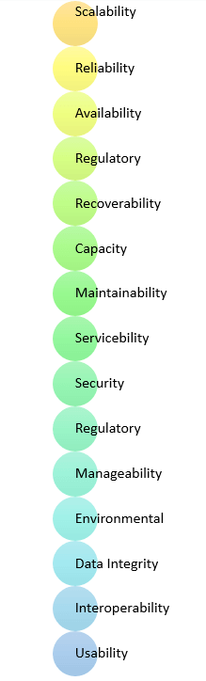

Advantages of Non-Functional Requirement
Benefits/pros of Non-functional testing are:
- The nonfunctional requirements ensure the software system follow legal and compliance rules.
- They ensure the reliability, availability, and performance of the software system
- They ensure good user experience and ease of operating the software.
- They help in formulating security policy of the software system.

Disadvantages of Non-functional requirement
Cons/drawbacks of Non-function requirement are:
- None functional requirement may affect the various high-level software subsystem
- They require special consideration during the software architecture/high-level design phase which increases costs.
- Their implementation does not usually map to the specific software sub-system,
- It is tough to modify non-functional once you pass the architecture phase.

*KEY LEARNING
- A non-functional requirement defines the performance attribute of a software system.
- Types of Non-functional requirement are Scalability Capacity, Availability, Reliability, Recoverability, Data Integrity, etc.
- Example of Non Functional Requirement is Employees never allowed to update their salary information. Such attempt should be reported to the security administrator.
- Functional Requirement is a verb while Non-Functional Requirement is an attribute
- The advantage of Non-functional requirement is that it helps you to ensure good user experience and ease of operating the software
- The biggest disadvantage of Non-functional requirement is that it may affect the various high-level software subsystems.

3.5 FEASIBILITY STUDY

The feasibility of the project is analyzed in this phase and business proposal is put forth with a very general plan for the project and some cost estimates. During system analysis the feasibility study of the proposed system is to be carried out. This is to ensure that the proposed system is not a burden to the company. For feasibility analysis, some understanding of the major requirements for the system is essential.

Three key considerations involved in the feasibility analysis are

- ECONOMICAL FEASIBILITY

- TECHNICAL FEASIBILITY

- SOCIAL FEASIBILITY

ECONOMICAL FEASIBILITY

This study is carried out to check the economic impact that the system will have on the organization. The amount of fund that the company can pour into the research and development of the system is limited. The expenditures must be justified. Thus the developed system as well within the budget and this was achieved because most of the technologies used are freely available. Only the customized products had to be purchased.

TECHNICAL FEASIBILITY

This study is carried out to check the technical feasibility, that is, the technical requirements of the system. Any system developed must not have a high demand on the available technical resources. This will lead to high demands on the available technical resources. This will lead to high demands being placed on the client. The developed system must have a modest requirement, as only minimal or null changes are required for implementing this system.

3.6SOCIAL FEASIBILITY
The aspect of study is to check the level of acceptance of the system by the user. This includes the process of training the user to use the system efficiently. The user must not feel threatened by the system, instead must accept it as a necessity. The level of acceptance by the users solely depends on the methods that are employed to educate the user about the system and to make him familiar with it. His level of confidence must be raised so that he is also able to make some constructive criticism, which is welcomed, as he is the final user of the system.

3.6REQUIREMENT SPECIFICATION

3.6.1 Hardware Requirements

➢ PROCESSOR - Intel Core i3/i5
➢ RAM - 4 GB
➢ HARD DISK - 500 GB

3.6.2 Software Requirements

- Operating system : Windows 8, Windows 10
- Coding Language : PYTHON
- Documentation : MS Office

4 SYSTEM DESIGN
4.1MODULE DESCRIPTION

1. Dataset Preparation:
The dataset consists of images labeled as "Fire" and "No-Fire".
The dataset images are preprocessed, including resizing to 32x32 pixels and normalization.
The images are loaded into numpy arrays, and corresponding labels are assigned (1 for "Fire" and 0 for "No-Fire").
The dataset is split into training and testing sets using an 80-20 split.
2. Model Building:
Support Vector Machine (SVM):
The color features of the images are extracted and reshaped to fit the SVM model.
SVM classifier is trained using the training dataset.
The trained SVM model is saved for future use.
VGG16-Based ReduceNet:
VGG16 model is imported as a base classifier.
Top layers of VGG16 are removed, and additional layers are added to create a reduced VGG16-based model.
Model is compiled using the Adam optimizer and categorical cross-entropy loss.
If weights for the model do not exist, the model is trained for 20 epochs, and weights are saved for future use.
VGG19-Based ReduceNet (Extension):
Similar to VGG16, VGG19 model is imported as a base classifier.
Top layers of VGG19 are removed, and additional layers are added to create a reduced VGG19-based model.
Model is compiled and trained similar to VGG16-based ReduceNet.
3. Model Evaluation:
Various metrics such as accuracy, precision, recall, and F1-score are calculated for each model.
Confusion matrices are generated to visualize the performance of the models.
Metrics are compared across different models (SVM, VGG16-Based ReduceNet, VGG19-Based ReduceNet).
4. Prediction:
A function is defined to predict fire or no-fire from test images.
Test images are resized, normalized, and passed through the VGG19-Based ReduceNet model for prediction.
The predicted class label along with the input image is displayed.
5. Fire Detection from Video:
Video is loaded, and each frame is passed through the VGG19-Based ReduceNet model for prediction.
If fire is detected in a frame, it is annotated with a bounding box.
Predicted class label and annotated frame are displayed in real-time.

FOREST WILDFIRE DATASET:
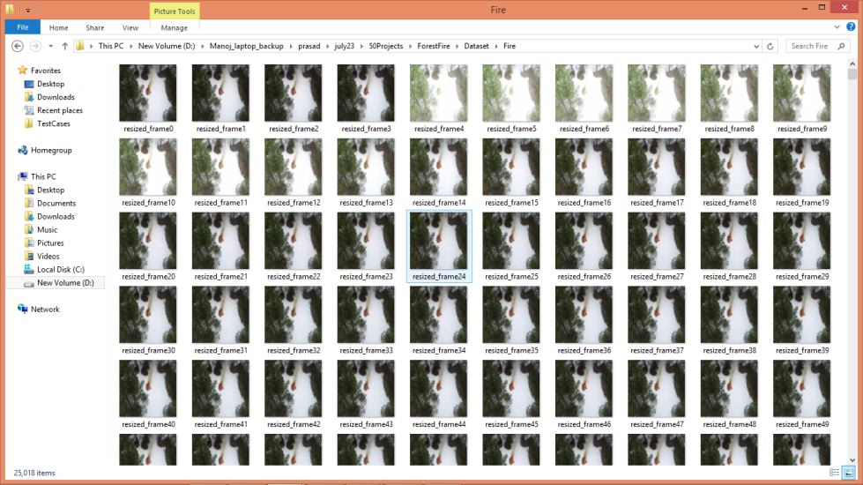
In above we can see images with fire so by using above images we will train and test all algorithms

4.2SYSTEM ARCHITECTURE:

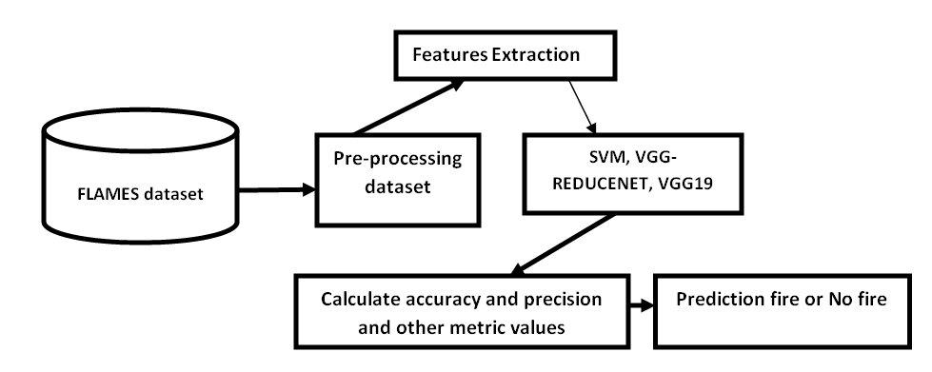

FIG1: Architecture

4.4 UML DIAGRAMS

UML stands for Unified Modeling Language. UML is a standardized general-purpose modeling language in the field of object-oriented software engineering. The standard is managed, and was created by, the Object Management Group.

The goal is for UML to become a common language for creating models of object oriented computer software. In its current form UML is comprised of two major components: a Meta-model and a notation. In the future, some form of method or process may also be added to; or associated with, UML.

The Unified Modeling Language is a standard language for specifying, Visualization, Constructing and documenting the artifacts of software system, as well as for business modeling and other non-software systems.

The UML represents a collection of best engineering practices that have proven successful in the modeling of large and complex systems.

The UML is a very important part of developing objects oriented software and the software development process. The UML uses mostly graphical notations to express the design of software projects.

GOALS:

The Primary goals in the design of the UML are as follows:

- Provide users a ready-to-use, expressive visual modeling Language so that they can develop and exchange meaningful models.

- Provide extendibility and specialization mechanisms to extend the core concepts.

- Be independent of particular programming languages and development process.

- Provide a formal basis for understanding the modeling language.

- Encourage the growth of OO tools market.

- Support higher level development concepts such as collaborations, frameworks, patterns and components.

- Integrate best practices.

4.4.1 USE CASE DIAGRAM

A use case diagram in the Unified Modeling Language (UML) is a type of behavioral diagram defined by and created from a Use-case analysis. Its purpose is to present a graphical overview of the functionality provided by a system in terms of actors, their goals (represented as use cases), and any dependencies between those use cases. The main purpose of a use case diagram is to show what system functions are performed for which actor. Roles of the actors in the system can be depicted

FIGURE 4.2.1 USECASE DIAGRAM

4.4.2 CLASS DIAGRAM

In software engineering, a class diagram in the Unified Modeling Language (UML) is a type of static structure diagram that describes the structure of a system by showing the system's classes, their attributes, operations (or methods), and the relationships among the classes. It explains which class contains information.

FIGURE 4.2.2 CLASS DIAGRAM

4.4.3 SEQUENCE DIAGRAM

A sequence diagram in Unified Modeling Language (UML) is a kind of interaction diagram that shows how processes operate with one another and in what order. It is a construct of a Message Sequence Chart. Sequence diagrams are sometimes called event diagrams, event scenarios, and timing diagrams.

FIGURE 4.2.3 SEQUENCE DIAGRAM

4.4.4 COLLABORATION DIAGRAM

The collaboration diagram is used to show the relationship between the objects in a system. Both the sequence and the collaboration diagrams represent the same information but differently. Instead of showing the flow of messages, it depicts the architecture of the object residing in the system as it is based on object-oriented programming. An object consists of several features. Multiple objects present in the system are connected to each other. The collaboration diagram, which is also known as a communication diagram, is used to portray the object's architecture in the system.
4.4.4 COLLABORATION DIAGRAM

5 TECHNOLOGY DESCRIPTIONS

5.1 Python Introduction
Python is a general purpose, dynamic, high level and interpreted programming language. It supports Object Oriented programming approach to develop applications. It is simple and easy to learn and provides lots of high-level data structures.
Python is easy to learn yet powerful and versatile scripting language which makes it attractive for Application Development.
Python's syntax and dynamic typing with its interpreted nature, makes it an ideal language for scripting and rapid application development.
Python supports multiple programming pattern, including object oriented, imperative and functional or procedural programming styles.
Python is not intended to work on special area such as web programming. That is why it is known as multipurpose because it can be used with web, enterprise, 3D CAD etc.
We don't need to use data types to declare variable because it is dynamically typed so we can write a=10 to assign an integer value in an integer variable.
Python makes the development and debugging fast because there is no compilation step included in python development and edit-test-debug cycle is very fast.

Python History
- Python laid its foundation in the late 1980s.
- The implementation of Python was started in the December 1989 by Guido Van Rossum at CWI in Netherland.
- In February 1991, van Rossum published the code (labeled version 0.9.0) to alt.sources.
- In 1994, Python 1.0 was released with new features like: lambda, map, filter, and reduce.
- Python 2.0 added new features like: list comprehensions, garbage collection system.
- On December 3, 2008, Python 3.0 (also called "Py3K") was released. It was designed to rectify fundamental flaw of the language.
- ABC programming language is said to be the predecessor of Python language which was capable of Exception Handling and interfacing with Amoeba Operating System.
- Python is influenced by following programming languages:
  - ABC language.
  - Modula-3

Python Features
Python provides lots of features that are listed below.

1) Easy to Learn and Use
Python is easy to learn and use. It is developer-friendly and high level programming language.

2) Expressive Language
Python language is more expressive means that it is more understandable and readable.

3) Interpreted Language
Python is an interpreted language i.e. interpreter executes the code line by line at a time. This makes debugging easy and thus suitable for beginners.

4) Cross-platform Language
Python can run equally on different platforms such as Windows, Linux, Unix and Macintosh etc. So, we can say that Python is a portable language.

5) Free and Open Source
Python language is freely available at offical web address.The source-code is also available. Therefore it is open source.

6) Object-Oriented Language
Python supports object oriented language and concepts of classes and objects come into existence.

7) Extensible
It implies that other languages such as C/C++ can be used to compile the code and thus it can be used further in our python code.

8) Large Standard Library
Python has a large and broad library and prvides rich set of module and functions for rapid application development.

9) GUI Programming Support
Graphical user interfaces can be developed using Python.

10) Integrated
It can be easily integrated with languages like C, C++, JAVA etc.

Python Applications
Python is known for its general purpose nature that makes it applicable in almost each domain of software development. Python as a whole can be used in any sphere of development.
Here, we are specifing applications areas where python can be applied.

1) Web Applications
We can use Python to develop web applications. It provides libraries to handle internet protocols such as HTML and XML, JSON, Email processing, request, beautifulSoup, Feedparser etc. It also provides Frameworks such as Django, Pyramid, Flask etc to design and delelop web based applications. Some important developments are: PythonWikiEngines, Pocoo, PythonBlogSoftware etc.

2) Desktop GUI Applications
Python provides Tk GUI library to develop user interface in python based application. Some other useful toolkits wxWidgets, Kivy, pyqt that are useable on several platforms. The Kivy is popular for writing multitouch applications.

3) Software Development
Python is helpful for software development process. It works as a support language and can be used for build control and management, testing etc.

4) Scientific and Numeric
Python is popular and widely used in scientific and numeric computing. Some useful library and package are SciPy, Pandas, IPython etc. SciPy is group of packages of engineering, science and mathematics.

5) Business Applications
Python is used to build Bussiness applications like ERP and e-commerce systems. Tryton is a high level application platform.

6) Console Based Application
We can use Python to develop console based applications. For example: IPython.

7) Audio or Video based Applications
Python is awesome to perform multiple tasks and can be used to develop multimedia applications. Some of real applications are: TimPlayer, cplay etc.

8) 3D CAD Applications
To create CAD application Fandango is a real application which provides full features of CAD.

9) Enterprise Applications
Python can be used to create applications which can be used within an Enterprise or an Organization. Some real time applications are: OpenErp, Tryton, Picalo etc.

10) Applications for Images
Using Python several application can be developed for image. Applications developed are: VPython, Gogh, imgSeek etc.
There are several such applications which can be developed using Python

How to Install Python (Environment Set-up)
In this section of the tutorial, we will discuss the installation of python on various operating systems.

Why Python
- Python works on different platforms (Windows, Mac, Linux, Raspberry Pi, etc).
- Python has a simple syntax similar to the English language.
- Python has syntax that allows developers to write programs with fewer lines than some other programming languages.
- Python runs on an interpreter system, meaning that code can be executed as soon as it is written. This means that prototyping can be very quick.
- Python can be treated in a procedural way, an object-orientated way or a functional way.

Good to know
- The most recent major version of Python is Python 3, which we shall be using in this tutorial. However, Python 2, although not being updated with anything other than security updates, is still quite popular.
- In this tutorial Python will be written in a text editor. It is possible to write Python in an Integrated Development Environment, such as Thonny, Pycharm, Netbeans or Eclipse which are particularly useful when managing larger collections of Python files.

Python Syntax compared to other programming languages
- Python was designed for readability, and has some similarities to the English language with influence from mathematics.
- Python uses new lines to complete a command, as opposed to other programming languages which often use semicolons or parentheses.
- Python relies on indentation, using whitespace, to define scope; such as the scope of loops, functions and classes. Other programming languages often use curly-brackets for this purpose.

Installation on Windows
Visit the link https://www.python.org/downloads/ to download the latest release of Python. In this process, we will install Python 3.6.7 on our Windows operating system.
Double-click the executable file which is downloaded; the following window will open. Select Customize installation and proceed.
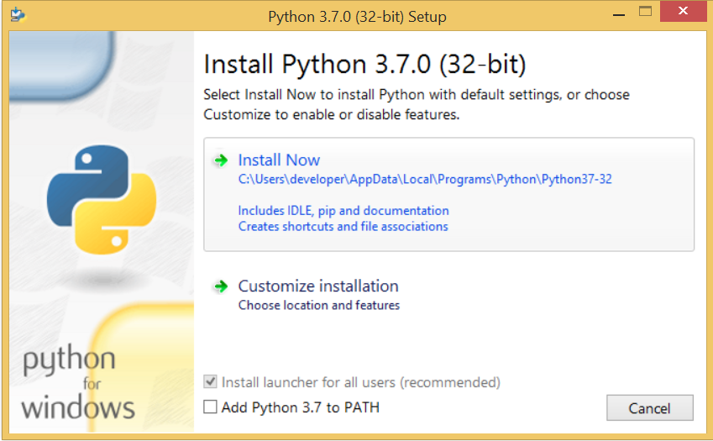
The following window shows all the optional features. All the features need to be installed and are checked by default; we need to click next to continue.
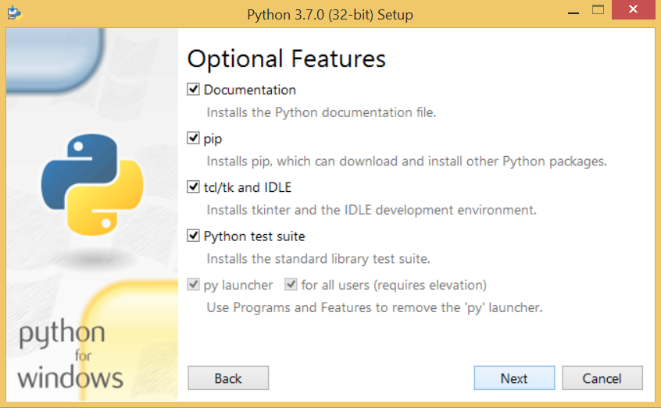
The following window shows a list of advanced options. Check all the options which you want to install and click next. Here, we must notice that the first check-box (install for all users) must be checked.
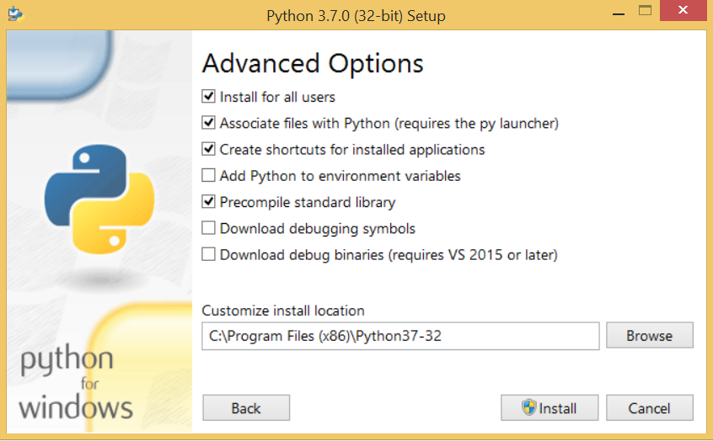
Now, we are ready to install python-3.6.6. Lets install it.
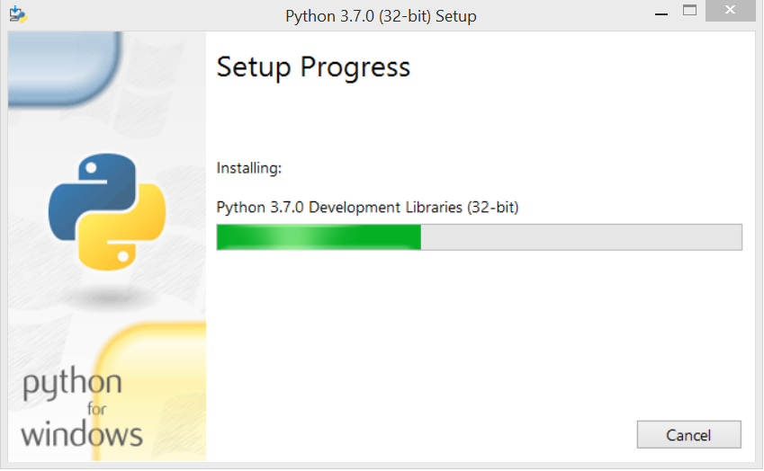
Now, try to run python on the command prompt. Type the command python in case of python2 or python3 in case of python3. It will show an error as given in the below image. It is because we haven't set the path.
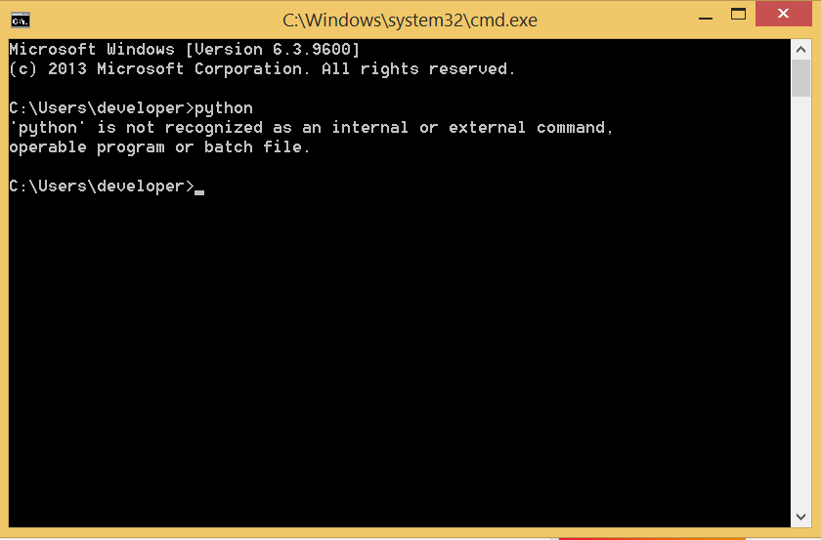
To set the path of python, we need to the right click on "my computer" and go to Properties → Advanced → Environment Variables.
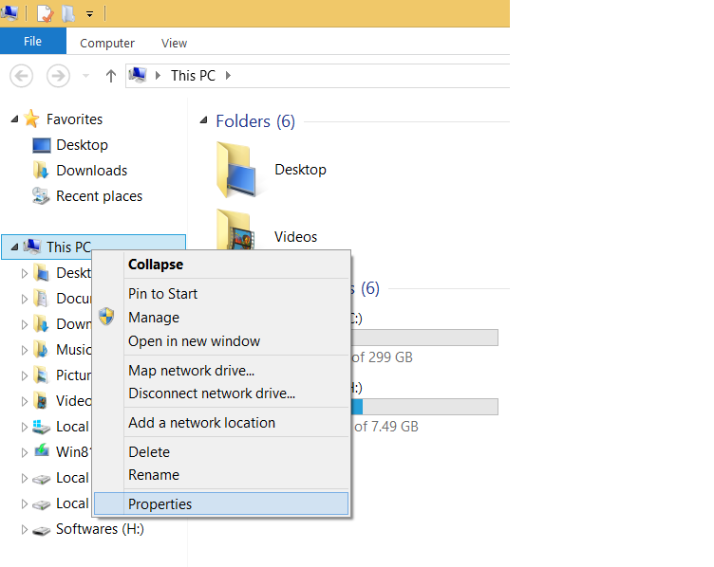
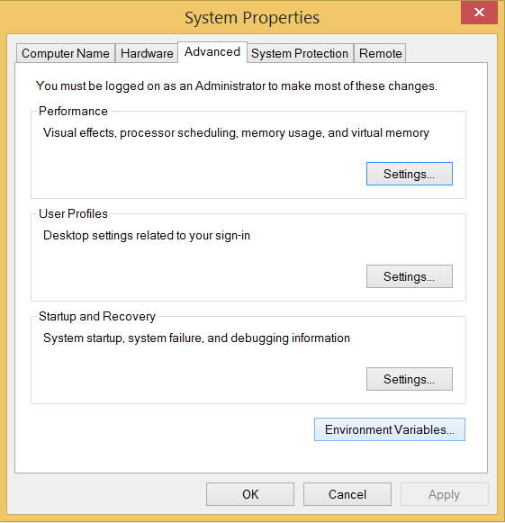
Add the new path variable in the user variable section.
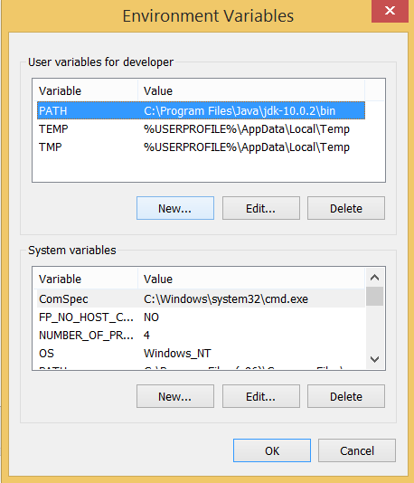
Type PATH as the variable name and set the path to the installation directory of the python shown in the below image.
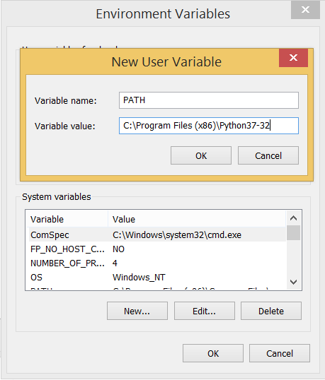
Now, the path is set, we are ready to run python on our local system. Restart CMD, and type python again. It will open the python interpreter shell where we can execute the python statements.
Virtual Environments and Packages
Introduction
Python applications will often use packages and modules that don’t come as part of the standard library. Applications will sometimes need a specific version of a library, because the application may require that a particular bug has been fixed or the application may be written using an obsolete version of the library’s interface.
This means it may not be possible for one Python installation to meet the requirements of every application. If application A needs version 1.0 of a particular module but application B needs version 2.0, then the requirements are in conflict and installing either version 1.0 or 2.0 will leave one application unable to run.
The solution for this problem is to create a virtual environment, a self-contained directory tree that contains a Python installation for a particular version of Python, plus a number of additional packages.
Different applications can then use different virtual environments. To resolve the earlier example of conflicting requirements, application A can have its own virtual environment with version 1.0 installed while application B has another virtual environment with version 2.0. If application B requires a library be upgraded to version 3.0, this will not affect application A’s environment.
Creating Virtual Environments
The module used to create and manage virtual environments is called venv. venv will usually install the most recent version of Python that you have available. If you have multiple versions of Python on your system, you can select a specific Python version by running python3 or whichever version you want.
To create a virtual environment, decide upon a directory where you want to place it, and run the venv module as a script with the directory path:
python3 -m venv tutorial-env
This will create the tutorial-env directory if it doesn’t exist, and also create directories inside it containing a copy of the Python interpreter, the standard library, and various supporting files.
A common directory location for a virtual environment is .venv. This name keeps the directory typically hidden in your shell and thus out of the way while giving it a name that explains why the directory exists. It also prevents clashing with .env environment variable definition files that some tooling supports.
Once you’ve created a virtual environment, you may activate it.
On Windows, run:
tutorial-env\Scripts\activate.bat
On Unix or MacOS, run:
source tutorial-env/bin/activate
(This script is written for the bash shell. If you use the csh or fish shells, there are alternate activate.csh and activate.fish scripts you should use instead.)
Activating the virtual environment will change your shell’s prompt to show what virtual environment you’re using, and modify the environment so that running python will get you that particular version and installation of Python. For example:
$ source ~/envs/tutorial-env/bin/activate
(tutorial-env) $ python
Python 3.5.1 (default, May 6 2016, 10:59:36)
...
>>> import sys
>>>sys.path
['', '/usr/local/lib/python35.zip', ...,
'~/envs/tutorial-env/lib/python3.5/site-packages']
>>>
Managing Packages with pip
You can install, upgrade, and remove packages using a program called pip. By default pip will install packages from the Python Package Index, <https://pypi.org>. You can browse the Python Package Index by going to it in your web browser, or you can use pip’s limited search feature:
(tutorial-env) $ pip search astronomy
skyfield - Elegant astronomy for Python
gary - Galactic astronomy and gravitational dynamics.
novas - The United States Naval Observatory NOVAS astronomy library
astroobs - Provides astronomy ephemeris to plan telescope observations
PyAstronomy - A collection of astronomy related tools for Python.
...
pip has a number of subcommands: “search”, “install”, “uninstall”, “freeze”, etc. (Consult the Installing Python Modules guide for complete documentation for pip.)
You can install the latest version of a package by specifying a package’s name:
(tutorial-env) $ pip install novas
Collecting novas
Downloading novas-3.1.1.3.tar.gz (136kB)
Installing collected packages: novas
Running setup.py install for novas
Successfully installed novas-3.1.1.3
You can also install a specific version of a package by giving the package name followed by == and the version number:
(tutorial-env) $ pip install requests==2.6.0
Collecting requests==2.6.0
Using cached requests-2.6.0-py2.py3-none-any.whl
Installing collected packages: requests
Successfully installed requests-2.6.0
If you re-run this command, pip will notice that the requested version is already installed and do nothing. You can supply a different version number to get that version, or you can run pip install --upgrade to upgrade the package to the latest version:
(tutorial-env) $ pip install --upgrade requests
Collecting requests
Installing collected packages: requests
Found existing installation: requests 2.6.0
Uninstalling requests-2.6.0:
Successfully uninstalled requests-2.6.0
Successfully installed requests-2.7.0
pip uninstall followed by one or more package names will remove the packages from the virtual environment.
pip show will display information about a particular package:
(tutorial-env) $ pip show requests
---
Metadata-Version: 2.0
Name: requests
Version: 2.7.0
Summary: Python HTTP for Humans.
Home-page: http://python-requests.org
Author: Kenneth Reitz
Author-email: me@kennethreitz.com
License: Apache 2.0
Location: /Users/akuchling/envs/tutorial-env/lib/python3.4/site-packages
Requires:
pip list will display all of the packages installed in the virtual environment:
(tutorial-env) $ pip list
novas (3.1.1.3)
numpy (1.9.2)
pip (7.0.3)
requests (2.7.0)
setuptools (16.0)
pip freeze will produce a similar list of the installed packages, but the output uses the format that pip install expects. A common convention is to put this list in a requirements.txt file:
(tutorial-env) $ pip freeze > requirements.txt
(tutorial-env) $ cat requirements.txt
novas==3.1.1.3
numpy==1.9.2
requests==2.7.0
The requirements.txt can then be committed to version control and shipped as part of an application. Users can then install all the necessary packages with install -r:

(tutorial-env) $ pip install -r requirements.txt
Collecting novas==3.1.1.3 (from -r requirements.txt (line 1))
...
Collecting numpy==1.9.2 (from -r requirements.txt (line 2))
...
Collecting requests==2.7.0 (from -r requirements.txt (line 3))
...
Installing collected packages: novas, numpy, requests
Running setup.py install for novas
Successfully installed novas-3.1.1.3 numpy-1.9.2 requests-2.7.0
pip has many more options. Consult the Installing Python Modules guide for complete documentation for pip. When you’ve written a package and want to make it available on the Python Package Index, consult the Distributing Python Modules guide.

6.SAMPLE CODE
#importing require python packages and classes
import os
import cv2
import numpy as np
from keras.utils.np_utils import to_categorical
from keras.layers import MaxPooling2D
from keras.layers import Dense, Dropout, Activation, Flatten, GlobalAveragePooling2D, BatchNormalization
from keras.layers import Convolution2D
from keras.models import Sequential
import pickle
from keras.applications import VGG16 #loading VGG16 as based classifier
from keras.applications import VGG19 #loading VGG19 as extension classifier
from sklearn.metrics import precision_score
from sklearn.metrics import recall_score
from sklearn.metrics import f1_score
from sklearn.metrics import accuracy_score
from sklearn.model_selection import train_test_split
from keras.callbacks import ModelCheckpoint
from sklearn import svm
from sklearn.metrics import confusion_matrix
import seaborn as sns
import matplotlib.pyplot as plt
#load dataset images
if os.path.exists('model/X.txt.npy'): #if dataset already process then load it
X = np.load('model/X.txt.npy')
Y = np.load('model/Y.txt.npy')
else: #if not process then process, saved and load for future execution
X = []
Y = []
path = 'Dataset'
for root, dirs, directory in os.walk(path):#loop all images in dataset
for j in range(len(directory)):
name = os.path.basename(root)
if 'Thumbs.db' not in directory[j]:
img = cv2.imread(root+"/"+directory[j]) #read image
img = cv2.resize(img, (32,32)) #resize image
im2arr = np.array(img)
im2arr = im2arr.reshape(32,32,3)
X.append(im2arr) #add images to array
if name == "Fire": #if fire then set label as 1 else 0 for non fire
Y.append(1)
else:
Y.append(0)
X = np.asarray(X)
Y = np.asarray(Y)
np.save('model/X.txt',X)
np.save('model/Y.txt',Y)
print("Dataset Loading Completed")
print("Total images found in dataset : "+str(X.shape[0]))
print("Classes found in dataset is Fire & No-Fire")
unqiue, count = np.unique(Y, return_counts = True)
height = count
bars = ['No Fire', 'Fire']
y_pos = np.arange(len(bars))
plt.bar(y_pos, height)
plt.xticks(y_pos, bars)
plt.xlabel("Dataset Class Label Graph")
plt.ylabel("Count")
plt.show()
Dataset Loading Completed
Total images found in dataset : 39375
Classes found in dataset is Fire & No-Fire

#display no fire image
no_fire = cv2.imread("Dataset/No_Fire/lake_resized_lake_frame22.jpg")
plt.imshow(no_fire)
plt.title('Processed No Fire Sample Image')
plt.axis('off')
plt.show()

#display fire image
fire = cv2.imread("Dataset/Fire/resized_frame1.jpg")
plt.imshow(cv2.cvtColor(fire, cv2.COLOR_RGB2BGR))
plt.title('Processed Fire Sample Image')
plt.axis('off')
plt.show()
#dataset preprocessing such as shuffling and normalization
X = X.astype('float32')
X = X/255 #normalizing images
indices = np.arange(X.shape[0])
np.random.shuffle(indices)#shuffling images
X = X[indices]
Y = Y[indices]
Y = to_categorical(Y)
print("Dataset Normalization & Shuffling Process completed")
Dataset Normalization & Shuffling Process completed

#now splitting dataset into train & test
X_train, X_test, y_train, y_test = train_test_split(X, Y, test_size=0.2) #split dataset into train and test
print()
print("Dataset train & test split as 80% dataset for training and 20% for testing")
print("Training Size (80%): "+str(X_train.shape[0])) #print training and test size
print("Testing Size (20%): "+str(X_test.shape[0]))
print()
Dataset train & test split as 80% dataset for training and 20% for testing
Training Size (80%): 31500
Testing Size (20%): 7875

In [22]:
#define global variables to calculate and store accuracy and other metrics
precision = []
recall = []
fscore = []
accuracy = []
In [23]:
#function to calculate various metrics such as accuracy, precision etc
def calculateMetrics(algorithm, predict, testY):
p = precision_score(testY, predict,average='macro') * 100
r = recall_score(testY, predict,average='macro') * 100
f = f1_score(testY, predict,average='macro') * 100
a = accuracy_score(testY,predict)*100
print()
print(algorithm+' Accuracy : '+str(a))
print(algorithm+' Precision : '+str(p))
print(algorithm+' Recall : '+str(r))
print(algorithm+' FMeasure : '+str(f))
accuracy.append(a)
precision.append(p)
recall.append(r)
fscore.append(f)
labels = ["No Fire", "Fire"]
conf_matrix = confusion_matrix(testY, predict)
plt.figure(figsize =(5, 5))
ax = sns.heatmap(conf_matrix, xticklabels = labels, yticklabels = labels, annot = True, cmap="viridis" ,fmt ="g");
ax.set_ylim([0,len(labels)])
plt.title(algorithm+" Confusion matrix")
plt.ylabel('True class')
plt.xlabel('Predicted class')
plt.show()
#now train SVM algorithm on color features
X_train1 = np.reshape(X_train, (X_train.shape[0], (X_train.shape[1] * X_train.shape[2] * X_train.shape[3])))
X_test1 = np.reshape(X_test, (X_test.shape[0], (X_test.shape[1] * X_test.shape[2] * X_test.shape[3])))
y_train1 = np.argmax(y_train, axis=1)
y_test1 = np.argmax(y_test, axis=1)
#now train SVM and then calculate accuracy on trained model
if os.path.exists("model/svm_model"):
f = open("model/svm_model", 'rb')
svm_cls = pickle.load(f)
f.close()
else:
svm_cls = svm.SVC(kernel="rbf")
svm_cls.fit(X_train1, y_train1)
f = open("model/svm_model", 'wb')
pickle.dump(svm_cls, f)
f.close()
predict = svm_cls.predict(X_test1)
calculateMetrics("SVM", predict, y_test1)

#now train propose VGG-Reducenet algorithm by applying VGG16 as transfer learning and in propose VGG-ReduceNet we are reducing
#VGG16 layers by setting to false
vgg = VGG16(include_top=False, weights='imagenet', input_shape=(X_train.shape[1], X_train.shape[2], X_train.shape[3]))
for layer in vgg.layers:
layer.trainable = False #reducing VGG16 layers
vggnet = Sequential()#creating own CNN object
vggnet.add(vgg)#adding VGG16 reduce layer object to new model as VGG ReduceNet
#define new layers for VGG reduceNet
vggnet.add(Convolution2D(32, (1 , 1), input_shape = (X_train.shape[1], X_train.shape[2], X_train.shape[3]), activation = 'relu'))
vggnet.add(MaxPooling2D(pool_size = (1, 1)))
vggnet.add(Convolution2D(32, (1, 1), activation = 'relu'))
vggnet.add(MaxPooling2D(pool_size = (1, 1)))
vggnet.add(Flatten())
vggnet.add(Dense(units = 256, activation = 'relu'))
vggnet.add(Dense(units = y_train.shape[1], activation = 'softmax'))
#compile and train model
vggnet.compile(optimizer = 'adam', loss = 'categorical_crossentropy', metrics = ['accuracy'])
if os.path.exists("model/vggnet_weights.hdf5") == False:
model_check_point = ModelCheckpoint(filepath='model/vggnet_weights.hdf5', verbose = 1, save_best_only = True)
hist = vggnet.fit(X_train, y_train, batch_size = 64, epochs = 20, validation_data=(X_test, y_test), callbacks=[model_check_point], verbose=1)
f = open('model/vggnet_history.pckl', 'wb')
pickle.dump(hist.history, f)
f.close()
else:
vggnet.load_weights("model/vggnet_weights.hdf5")
#perform prediction using VGGReduceNet and then calculate metrics
predict = vggnet.predict(X_test)
predict = np.argmax(predict, axis=1)
y_label = np.argmax(y_test, axis=1)
calculateMetrics("Propose VGG-ReduceNet", predict, y_label)
WARNING:tensorflow:From c:\users\user\appdata\local\programs\python\python37\lib\site-packages\keras\backend\tensorflow_backend.py:4070: The name tf.nn.max_pool is deprecated. Please use tf.nn.max_pool2d instead.

WARNING:tensorflow:From c:\users\user\appdata\local\programs\python\python37\lib\site-packages\keras\backend\tensorflow_backend.py:422: The name tf.global_variables is deprecated. Please use tf.compat.v1.global_variables instead.

#now as extension we are using VGG19 as transfer learning and then comparing its performnace with Propose VGG-ReduceNet
#creating VGG19 object
vgg = VGG19(include_top=False, weights='imagenet', input_shape=(X_train.shape[1], X_train.shape[2], X_train.shape[3]))
for layer in vgg.layers:
layer.trainable = False #setting VGG19 layers to reduce
vggnet_extension = Sequential()
#adding VGG19 as transer learning to make extension VGG
vggnet_extension.add(vgg)
#defining new layers for VGG extension
vggnet_extension.add(Convolution2D(32, (1 , 1), input_shape = (X_train.shape[1], X_train.shape[2], X_train.shape[3]), activation = 'relu'))
vggnet_extension.add(MaxPooling2D(pool_size = (1, 1)))
vggnet_extension.add(Convolution2D(32, (1, 1), activation = 'relu'))
vggnet_extension.add(MaxPooling2D(pool_size = (1, 1)))
vggnet_extension.add(Flatten())
vggnet_extension.add(Dense(units = 256, activation = 'relu'))
vggnet_extension.add(Dense(units = y_train.shape[1], activation = 'softmax'))
vggnet_extension.compile(optimizer = 'adam', loss = 'categorical_crossentropy', metrics = ['accuracy'])
#compiling and training model
if os.path.exists("model/extension_weights.hdf5") == False:
model_check_point = ModelCheckpoint(filepath='model/extension_weights.hdf5', verbose = 1, save_best_only = True)
hist = vggnet_extension.fit(X_train, y_train, batch_size = 64, epochs = 20, validation_data=(X_test, y_test), callbacks=[model_check_point], verbose=1)
f = open('model/extension_history.pckl', 'wb')
pickle.dump(hist.history, f)
f.close()
else:
vggnet_extension.load_weights("model/extension_weights.hdf5")
#perform prediction using VGG extension
predict = vggnet_extension.predict(X_test)
predict = np.argmax(predict, axis=1)
y_label = np.argmax(y_test, axis=1)
calculateMetrics("Extension VGG19-ReduceNet", predict, y_label)
import pandas as pd
df = pd.DataFrame([['Existing SVM','Precision',precision[0]],['Existing SVM','Recall',recall[0]],['Existing SVM','F1 Score',fscore[0]],['Existing SVM','Accuracy',accuracy[0]],
['Propose VGG16-ReduceNet','Precision',precision[1]],['Propose VGG16-ReduceNet','Recall',recall[1]],['Propose VGG16-ReduceNet','F1 Score',fscore[1]],['Propose VGG16-ReduceNet','Accuracy',accuracy[1]],
['Extension VGG19-ReduceNet','Precision',precision[2]],['Extension VGG19-ReduceNet','Recall',recall[2]],['Extension VGG19-ReduceNet','F1 Score',fscore[2]],['Extension VGG19-ReduceNet','Accuracy',accuracy[2]],
],columns=['Parameters','Algorithms','Value'])
df.pivot("Parameters", "Algorithms", "Value").plot(kind='bar')
plt.title("Existing SVM, Propose VGG16-ReduceNet & Extension VGG19-ReduceNet Performance Graph")
plt.show()
#showing all algorithms with scenario A and B performance values
columns = ["Algorithm Name","Precison","Recall","FScore","Accuracy"]
values = []
algorithm_names = ["Existing SVM","Propose VGG16 ReduceNet", "Extension VGG19 ReduceNet"]
for i in range(len(algorithm_names)):
values.append([algorithm_names[i],precision[i],recall[i],fscore[i],accuracy[i]])

temp = pd.DataFrame(values,columns=columns)
temp
def vibeAnnotate(img):
hsv = cv2.cvtColor(img, cv2.COLOR_BGR2HSV)
lower_red = np.array([0, 10, 120])
upper_red = np.array([15, 255, 255])
mask = cv2.inRange (hsv, lower_red, upper_red)
contours, _ = cv2.findContours(mask.copy(), cv2.RETR_TREE, cv2.CHAIN_APPROX_SIMPLE)
if len(contours) > 0:
for c in contours:
#red_area = max(contours, key=cv2.contourArea)
x, y, w, h = cv2.boundingRect(c)
if w >= 5 and h >= 10:
cv2.rectangle(img,(x, y),(x+w, y+h),(0, 0, 255), 2)
return img
#function to predict fire or no fire from images or videos
def predict(test_image):
labels = ['No Fire', 'Fire']
#reading test image as img variable
image = cv2.imread(test_image)
img = cv2.resize(image, (32,32))
im2arr = np.array(img)
im2arr = im2arr.reshape(1,32,32,3)
img = np.asarray(im2arr)
img = img.astype('float32')
img = img/255 #normalizing test image
predict = vggnet_extension.predict(img)#now using vgg19 extension to predict as fire or no fire
predict = np.argmax(predict)
img = cv2.imread(test_image)
img = cv2.resize(img, (600,400))
if predict == 1:
img = vibeAnnotate(img)
cv2.putText(img, 'Prediction Output : '+labels[predict]+" Detected", (10, 25), cv2.FONT_HERSHEY_SIMPLEX,0.7, (255, 0, 0), 2)
plt.figure(figsize=(8,8))
plt.imshow(cv2.cvtColor(img, cv2.COLOR_RGB2BGR))
#now detect fire from video
labels = ['No Fire', 'Fire']
filename = "testVideos/videoplayback.mp4" #loading video
video = cv2.VideoCapture(filename)
width = int(video.get(cv2.CAP_PROP_FRAME_WIDTH))
fps = int(video.get(cv2.CAP_PROP_FPS))
height = int(video.get(cv2.CAP_PROP_FRAME_HEIGHT))
while(True):
ret, frame = video.read()
img = cv2.resize(frame, (32,32))
im2arr = np.array(img)
im2arr = im2arr.reshape(1,32,32,3)
img = np.asarray(im2arr)
img = img.astype('float32')
img = img/255 #normalizing test image
predict = vggnet_extension.predict(img)#now using vgg19 extension to predict as fire or no fire
predict = np.argmax(predict)
if predict == 1:
frame = vibeAnnotate(frame)
cv2.putText(frame, 'Prediction Output : '+labels[predict]+" Detected", (10, 25), cv2.FONT_HERSHEY_SIMPLEX,0.7, (255, 0, 0), 2)
cv2.imshow("Frame", frame)
if cv2.waitKey(10) & 0xFF == ord('q'):
break
video.release()
cv2.destroyAllWindows()

7. TESTING

7.1 INTRODUCTION
In general, software engineers distinguish software faults from software failures. In case of a failure, the software does not do what the user expects. A fault is a programming error that may or may not actually manifest as a failure. A fault can also be described as an error in the correctness of the semantic of a computer program. A fault will become a failure if the exact computation conditions are met, one of them being that the faulty portion of computer software executes on the CPU. A fault can also turn into a failure when the software is ported to a different hardware platform or a different compiler, or when the software gets extended. Software testing is the technical investigation of the product under test to provide stakeholders with quality related information.
System Testing and Implementation
The purpose is to exercise the different parts of the module code to detect coding errors. After this the modules are gradually integrated into subsystems, which are then integrated themselves too eventually forming the entire system. During integration of module integration testing is performed. The goal of this is to detect designing errors, while focusing the interconnection between modules. After the system was put together, system testing is performed. Here the system is tested against the system requirements to see if all requirements were met and the system performs as specified by the requirements. Finally accepting testing is performed to demonstrate to the client for the operation of the system.
For the testing to be successful, proper selection of the test case is essential. There are two different approaches for selecting test case. The software or the module to be tested is treated as a black box, and the test cases are decided based on the specifications of the system or module. For this reason, this form of testing is also called “black box testing”.
The focus here is on testing the external behavior of the system. In structural testing the test cases are decided based on the logic of the module to be tested. A common approach here is to achieve some type of coverage of the statements in the code. The two forms of testing are complementary: one tests the external behavior, the other tests the internal structure.
Testing is an extremely critical and time-consuming activity. It requires proper planning of the overall testing process. Frequently the testing process starts with the test plan. This plan identifies all testing related activities that must be performed and specifies the schedule, allocates the resources, and specifies guidelines for testing. The test plan specifies conditions that should be tested; different units to be tested, and the manner in which the module will be integrated together. Then for different test unit, a test case specification document is produced, which lists all the different test cases, together with the expected outputs, that will be used for testing. During the testing of the unit the specified test cases are executed and the actual results are compared with the expected outputs. The final output of the testing phase is the testing report and the error report, or a set of such reports. Each test report contains a set of test cases and the result of executing the code with the test cases. The error report describes the errors encountered and the action taken to remove the error.
Testing Techniques
Testing is a process, which reveals errors in the program. It is the major quality measure employed during software development. During testing, the program is executed with a set of conditions known as test cases and the output is evaluated to determine whether the program is performing as expected. In order to make sure that the system does not have errors, the different levels of testing strategies that are applied at differing phases of software development are:
Black Box Testing
In this strategy some test cases are generated as input conditions that fully execute all functional requirements for the program. This testing has been uses to find errors in the following categories:
- Incorrect or missing functions
- Interface errors
- Errors in data structure or external database access
- Performance errors
- Initialization and termination errors.

In this testing only the output is checked for correctness. The logical flow of the data is not checked.
White Box Testing
In this testing, the test cases are generated on the logic of each module by drawing flow graphs of that module and logical decisions are tested on all the cases. It has been uses to generate the test cases in the following cases:
- Guarantee that all independent paths have been executed.
- Execute all logical decisions on their true and false sides
- Execute all loops at their boundaries and within their operational
- Execute internal data structures to ensure their validity.
Testing Strategies
Unit testing
Unit testing involves the design of test cases that validate that the internal program logic is functioning properly, and that program inputs produce valid outputs. All decision branches and internal code flow should be validated. It is the testing of individual software units of the application .it is done after the completion of an individual unit before integration. This is a structural testing, that relies on knowledge of its construction and is invasive. Unit tests perform basic tests at component level and test a specific business process, application, and/or system configuration. Unit tests ensure that each unique path of a business process performs accurately to the documented specifications and contains clearly defined inputs and expected results.
This System consists of 3 modules. Those are Reputation module, route discovery module, audit module. Each module is taken as unit and tested. Identified errors are corrected and executable unit are obtained.
Integration testing
Integration tests are designed to test integrated software components to determine if they actually run as one program. Testing is event driven and is more concerned with the basic outcome of screens or fields. Integration tests demonstrate that although the components were individually satisfaction, as shown by successfully unit testing, the combination of components is correct and consistent. Integration testing is specifically aimed at exposing the problems that arise from the combination of components.
System Testing
System testing ensures that the entire integrated software system meets requirements. It tests a configuration to ensure known and predictable results. An example of system testing is the configuration oriented system integration test. System testing is based on process descriptions and flows, emphasizing pre-driven process links and integration points.
Functional Testing
Functional tests provide systematic demonstrations that functions tested are available as specified by the business and technical requirements, system documentation, and user manuals.
Functional testing is centered on the following items
Valid Input : identified classes of valid input must be accepted
Invalid Input : identified classes of invalid input must be rejected.
Functions : identified functions must be exercised
Output : identified classes of application outputs must be exercised.
Systems/Procedures : interfacing systems or procedures must be invoked
Organization and preparation of functional tests is focused on requirements, key functions, or special test cases. In addition, systematic coverage pertaining to identify Business process flows; data fields, predefined processes, and successive processes.

- SCREENSHOTS

We have coded this project using JUPYTER notebook
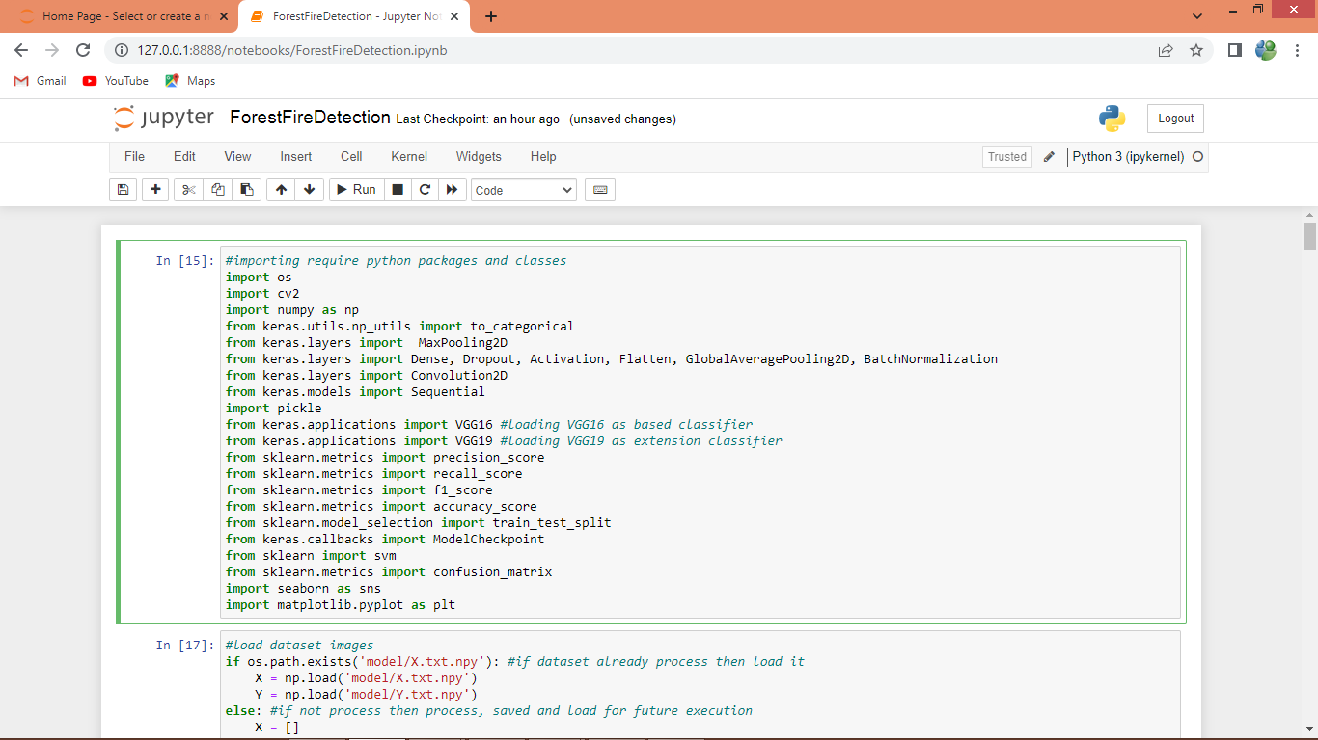
In above screen we are importing require python classes and packages
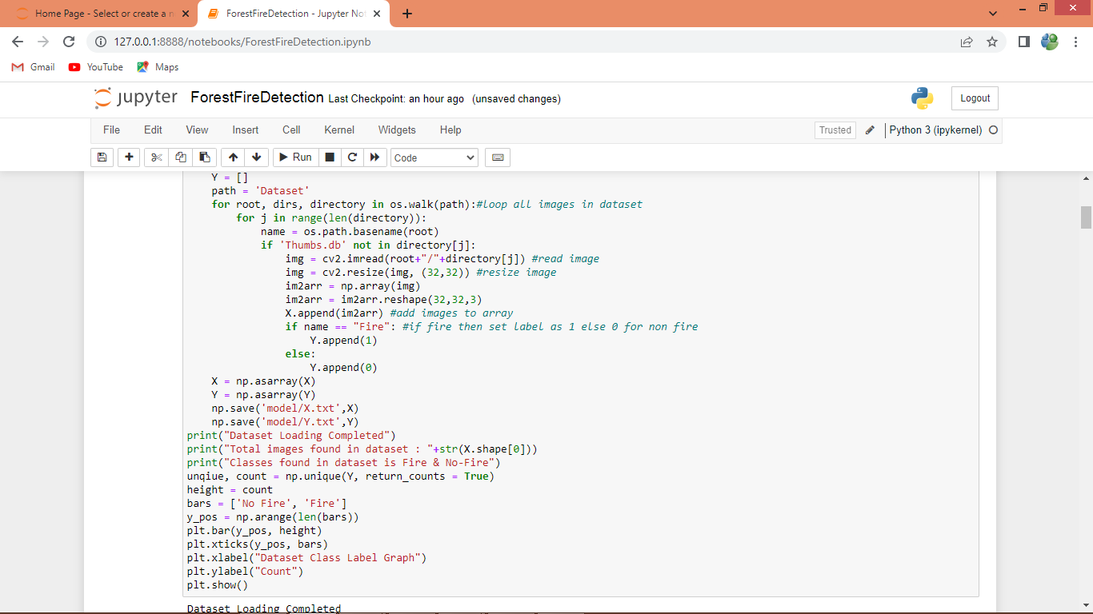
In above screen connecting to dataset folder and then looping and reading all images and then adding each image features to X array and label to Y array
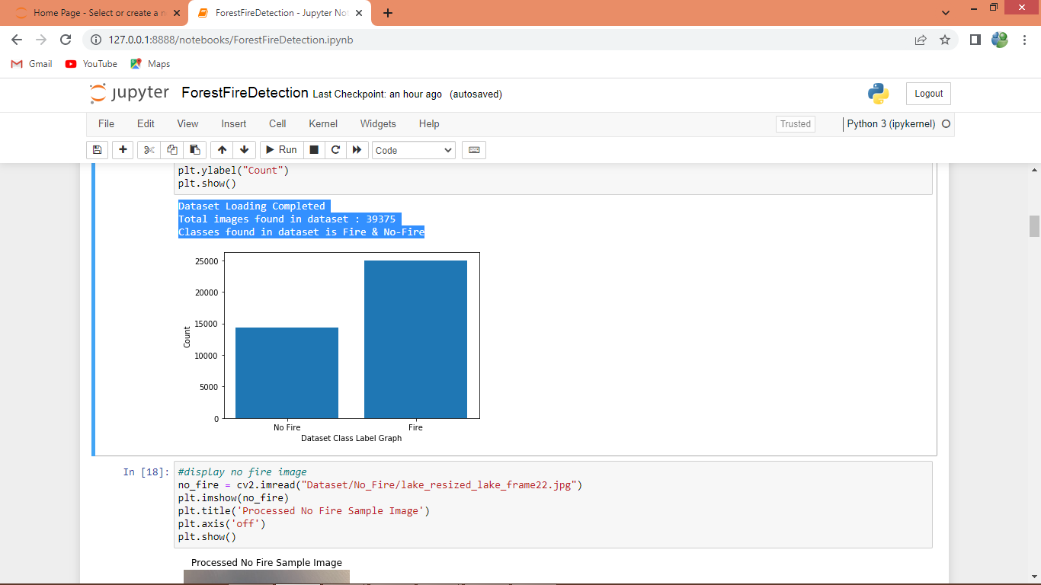
In above screen in blue colour text displaying total images loaded and in graph x-axis represents type of images as Fire or No-Fire and y-axis represents count.
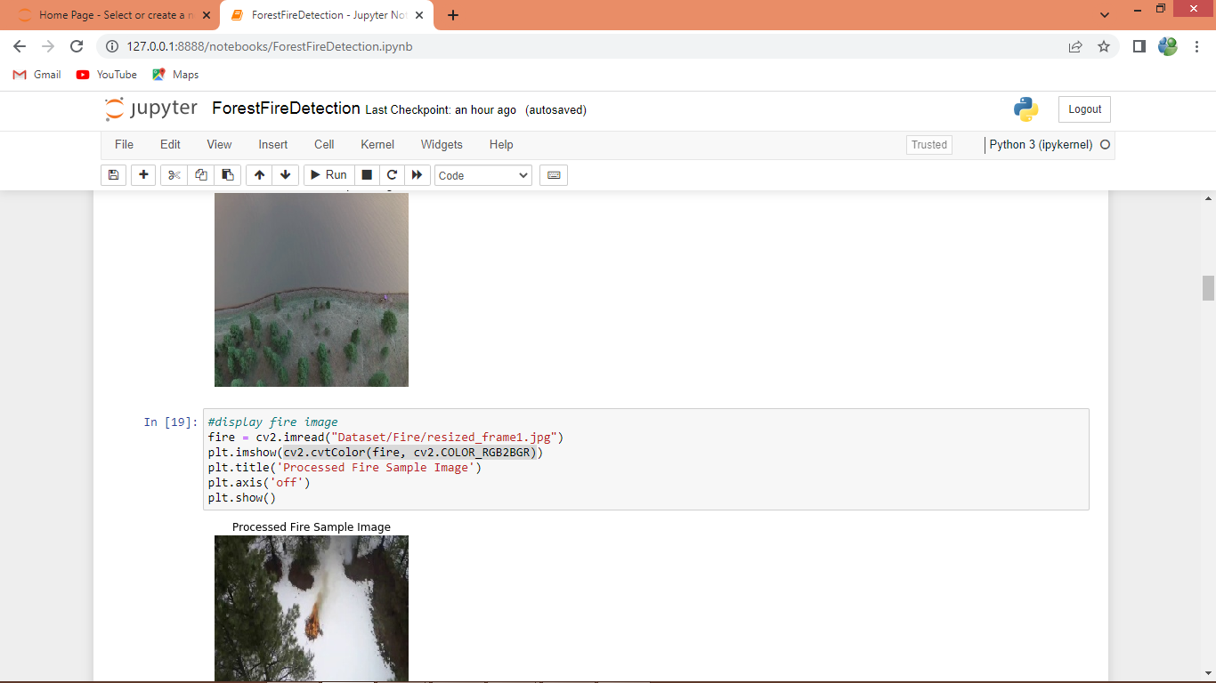
In above screen displaying processed images from dataset as Fire and NO Fire
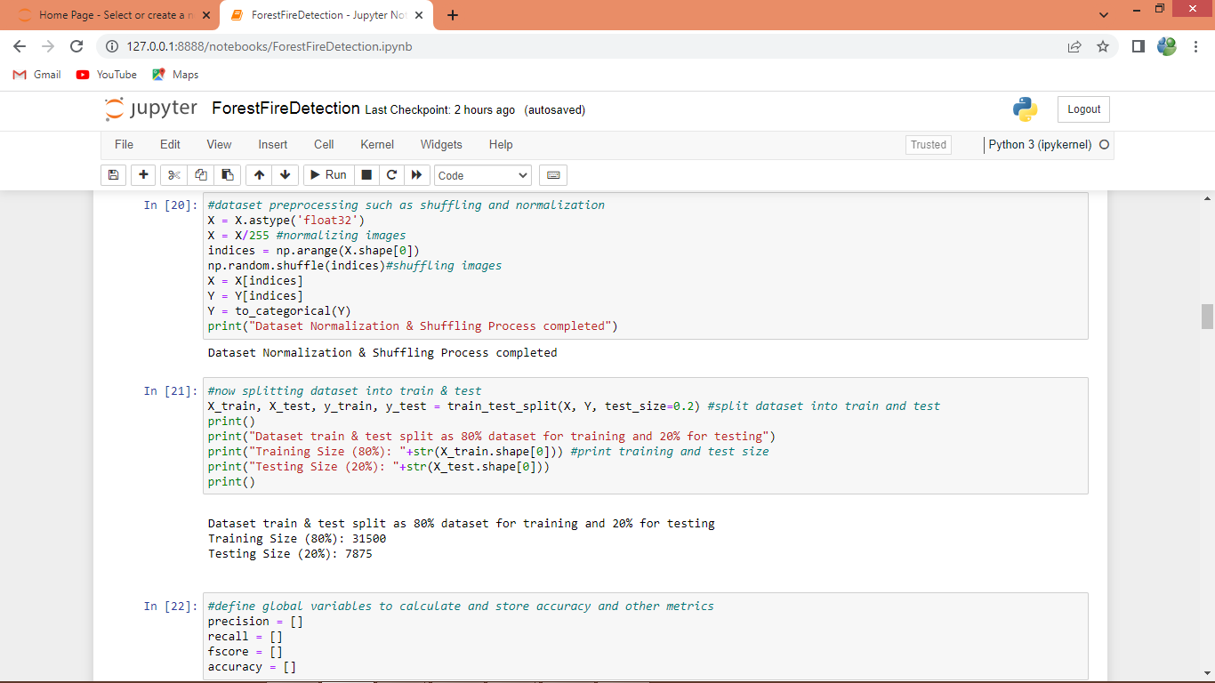
In above screen we are normalizing, shuffling and splitting dataset into train and test where application using 80% dataset images for training and 20% for testing
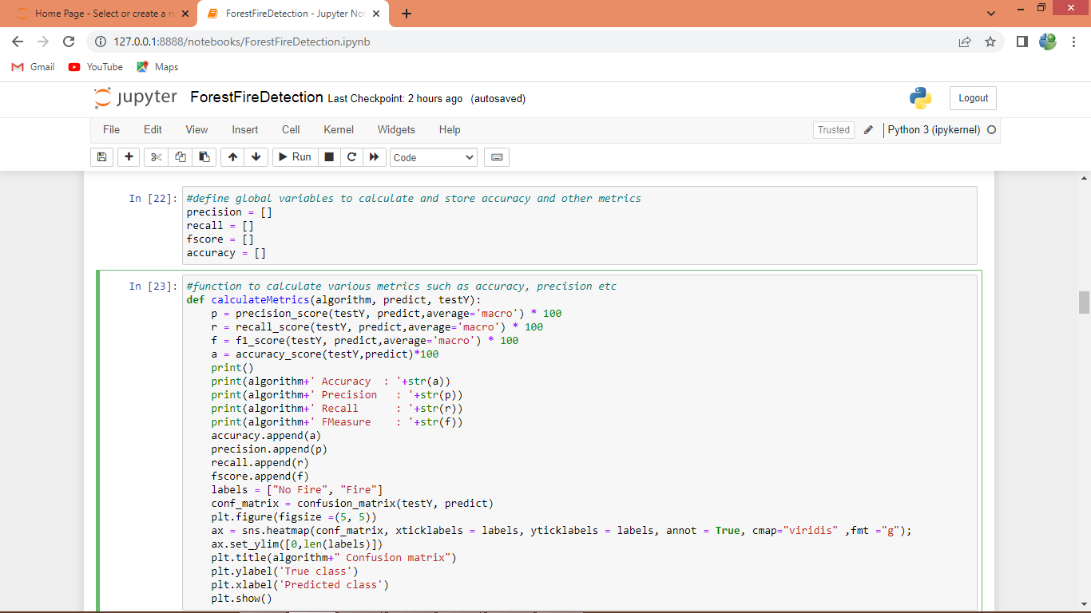
In above screen we are defining function to calculate accuracy and other metrics
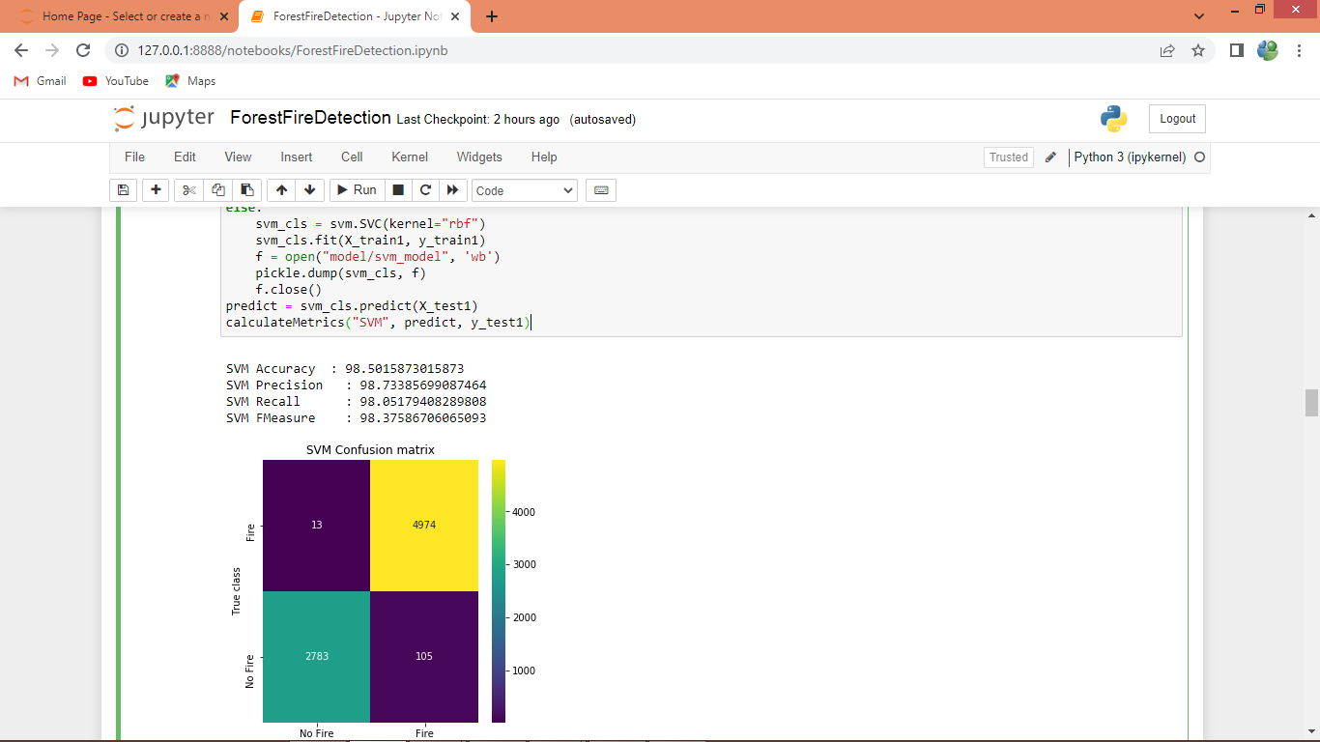
In above screen we are training SVM on train data and then evaluating its performance on test data and then SVM got 98% accuracy. In confusion matrix graph x-axis represents Predicted Labels and y-axis represents True Labels where blue boxes represents incorrect prediction count which are very few and yellow and light green boxes represents correct prediction count.
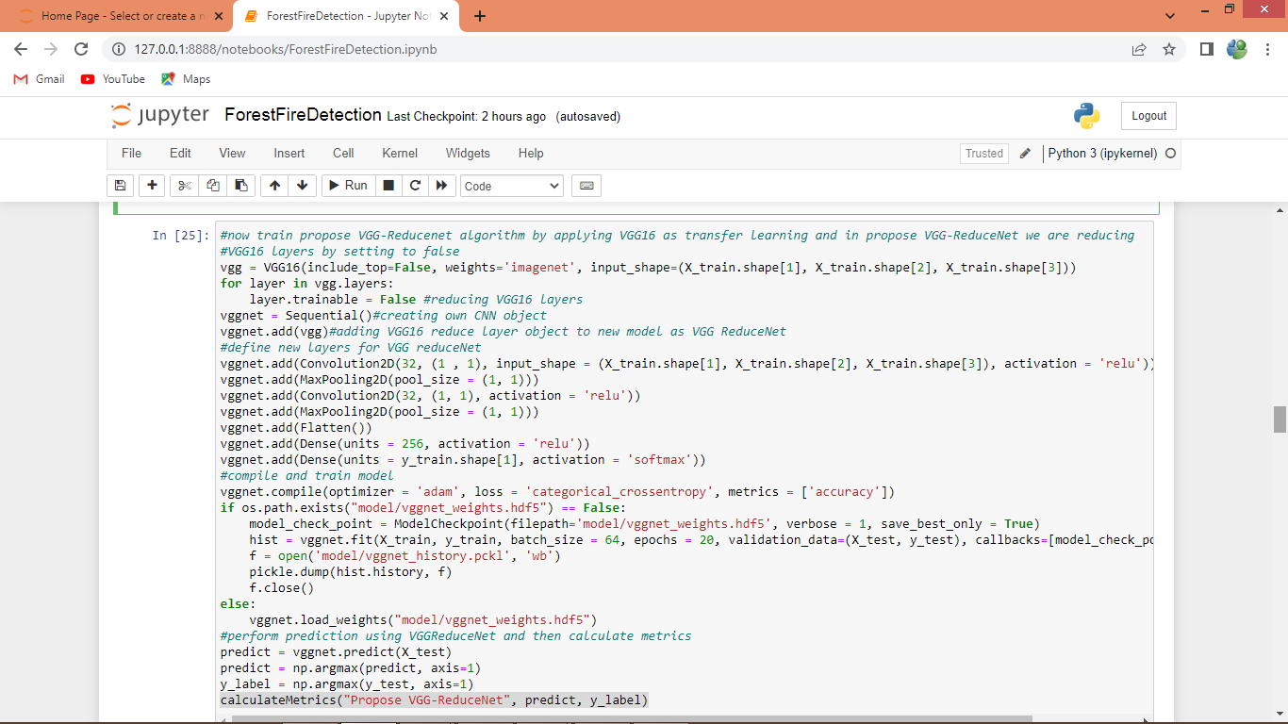
In above screen we are defining VGG16 as based classifier and then forming new model called VGG-REDUCENET by adding layers to extract Temporal and spatial features and after executing above model will get below output
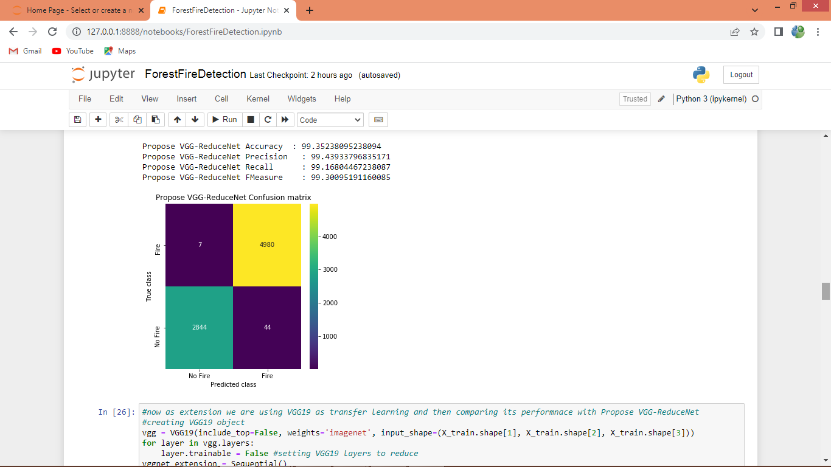
In above screen with propose VGGREDUCENET we got 99.35% accuracy and we can see other metrics also
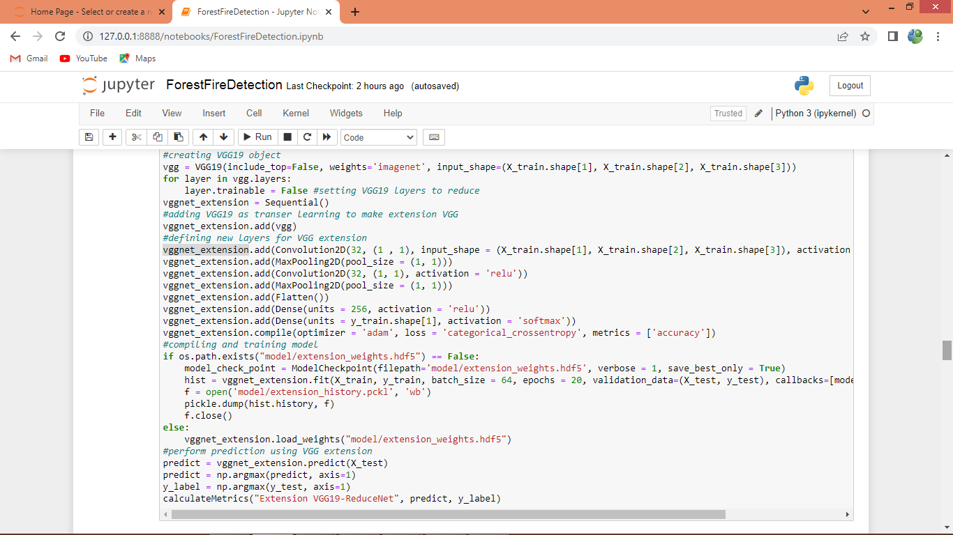
In above screen defining Extension model by using VGG19 as the based classifier and then defining new layers to extract spatial and temporal features and after executing above model will get below output
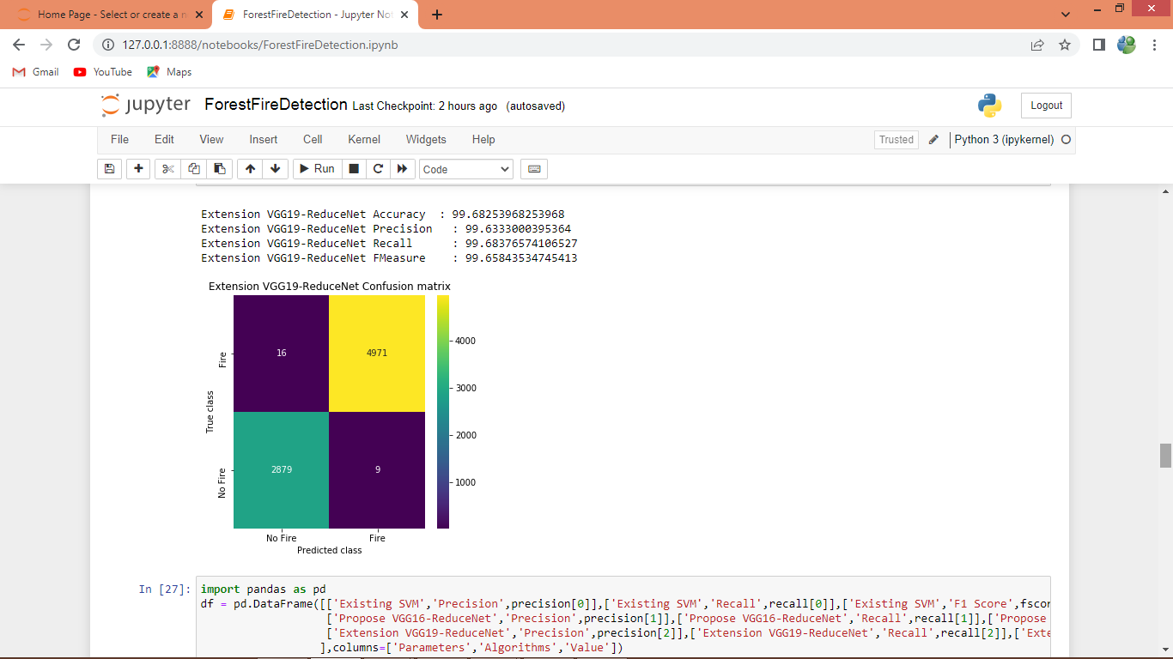
In above screen with extension model we got 99.68% accuracy and below are the comparison graph between all algorithms
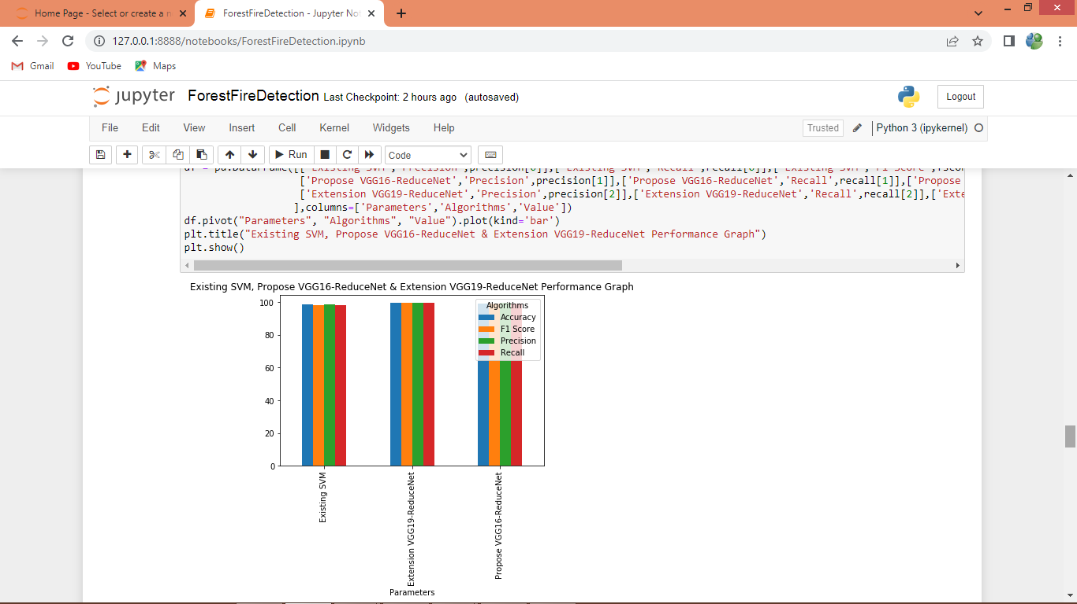
In above graph x-axis represents algorithm names and y-axis represents accuracy and other metrics in different colour bars and in all algorithms extension got high performance
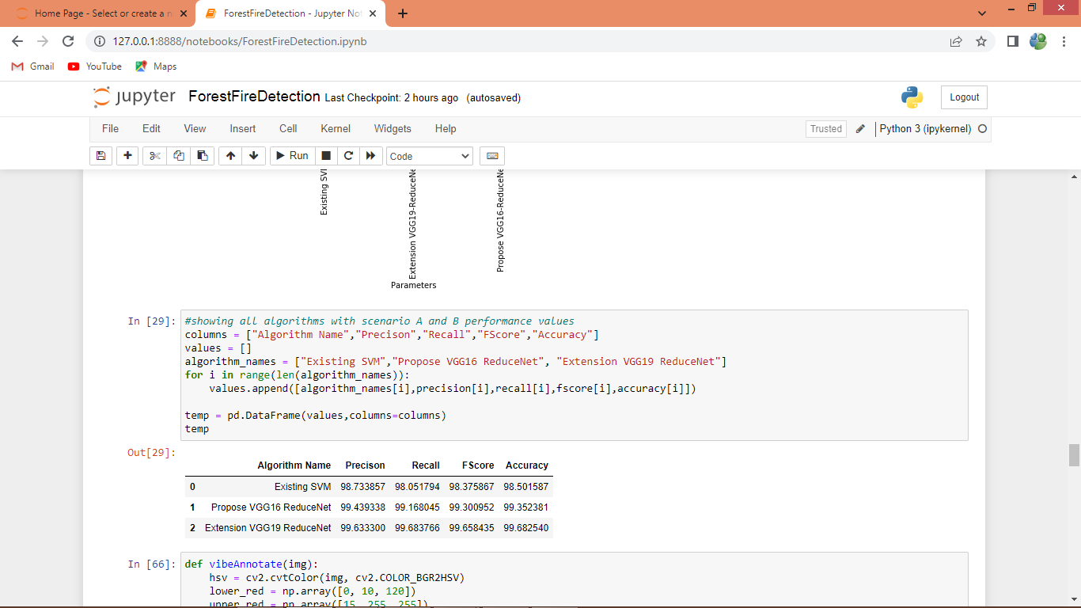
In above screen we can see each algorithm performance in tabular format
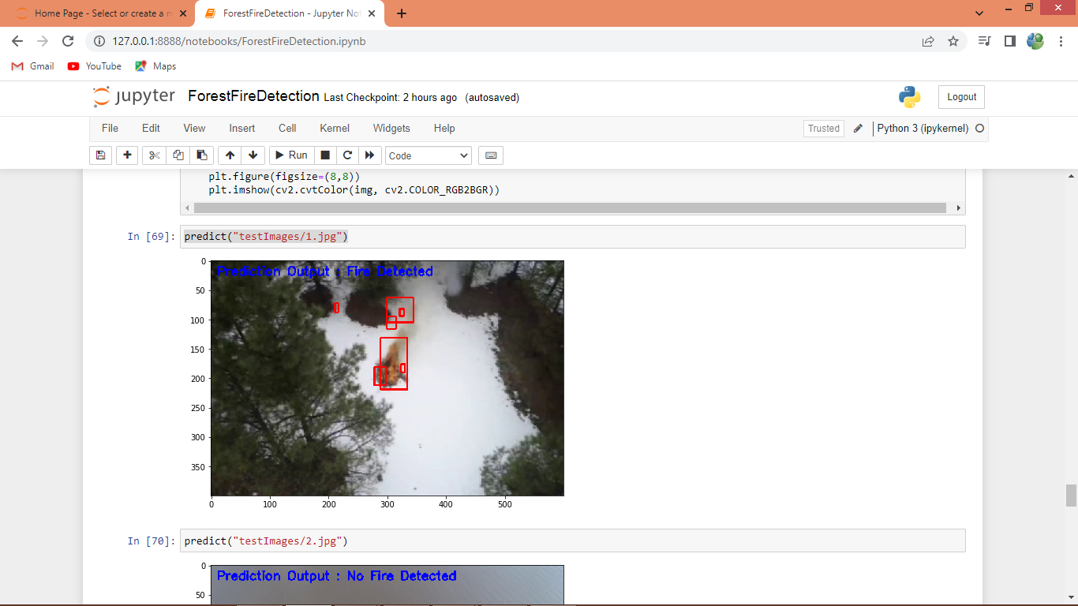
In above screen we are predicting on test image and in above image we got two output where first output showing ‘image contains fire’ and other output annotating image with red colour bounding box
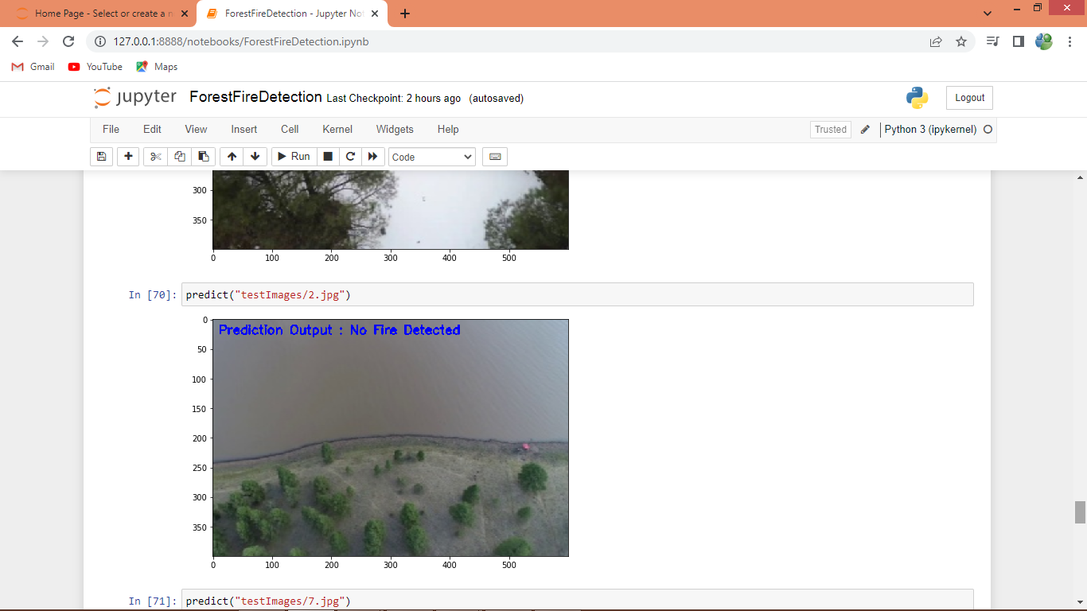
In above image ‘fire is not detected’
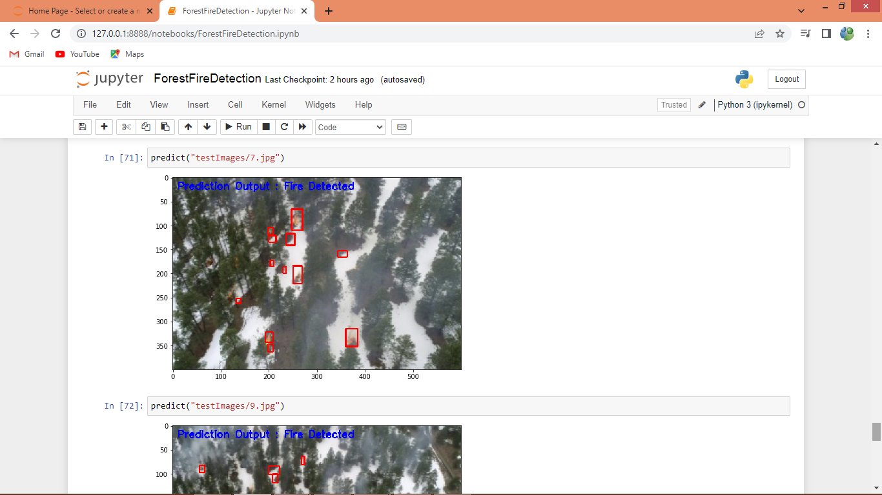
In above screen fire is detected and annotated and we got above output on images and below are the output prediction from VIDEOS
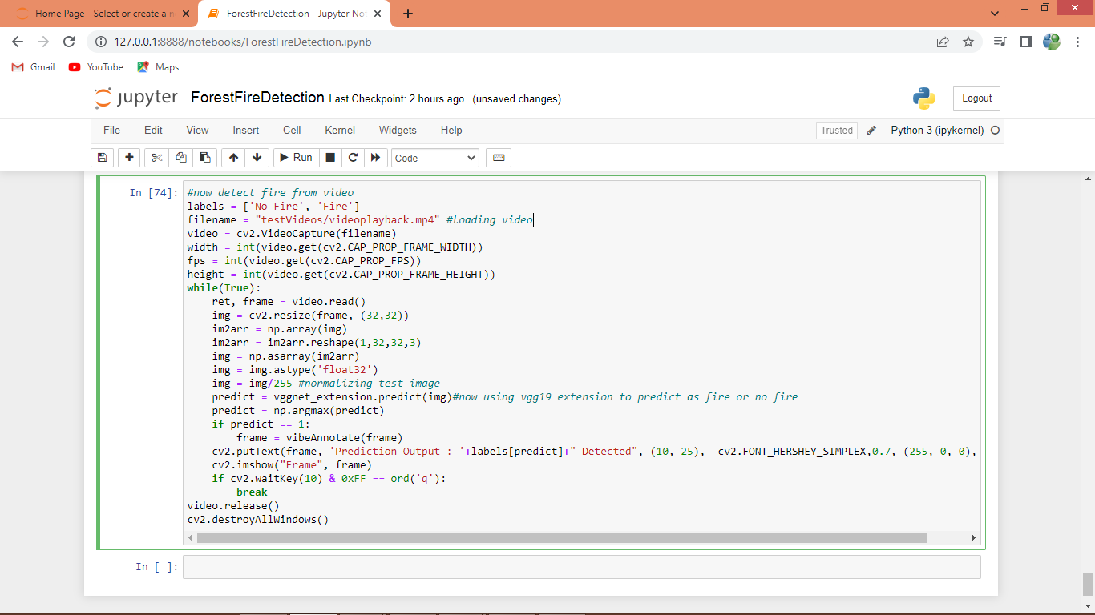
In above code we are predicting on video and below is the output video
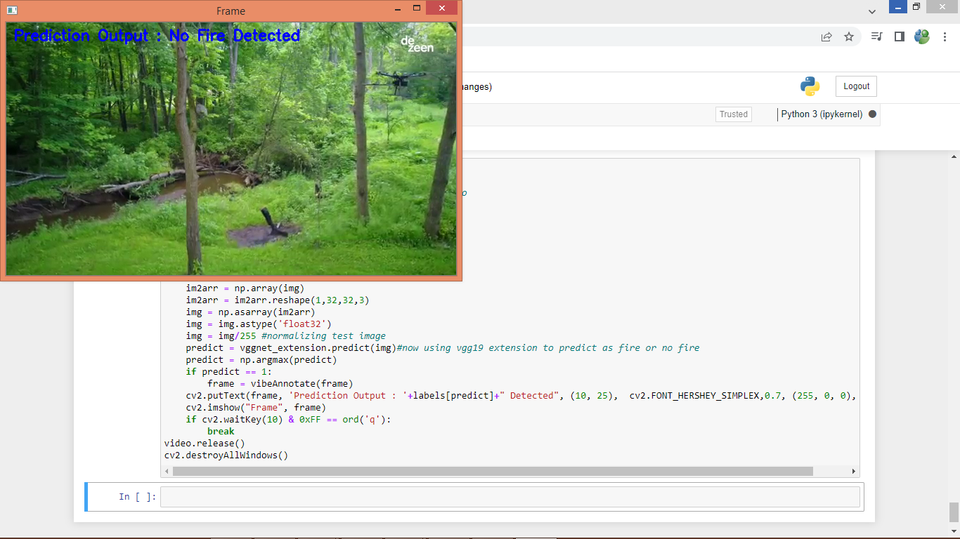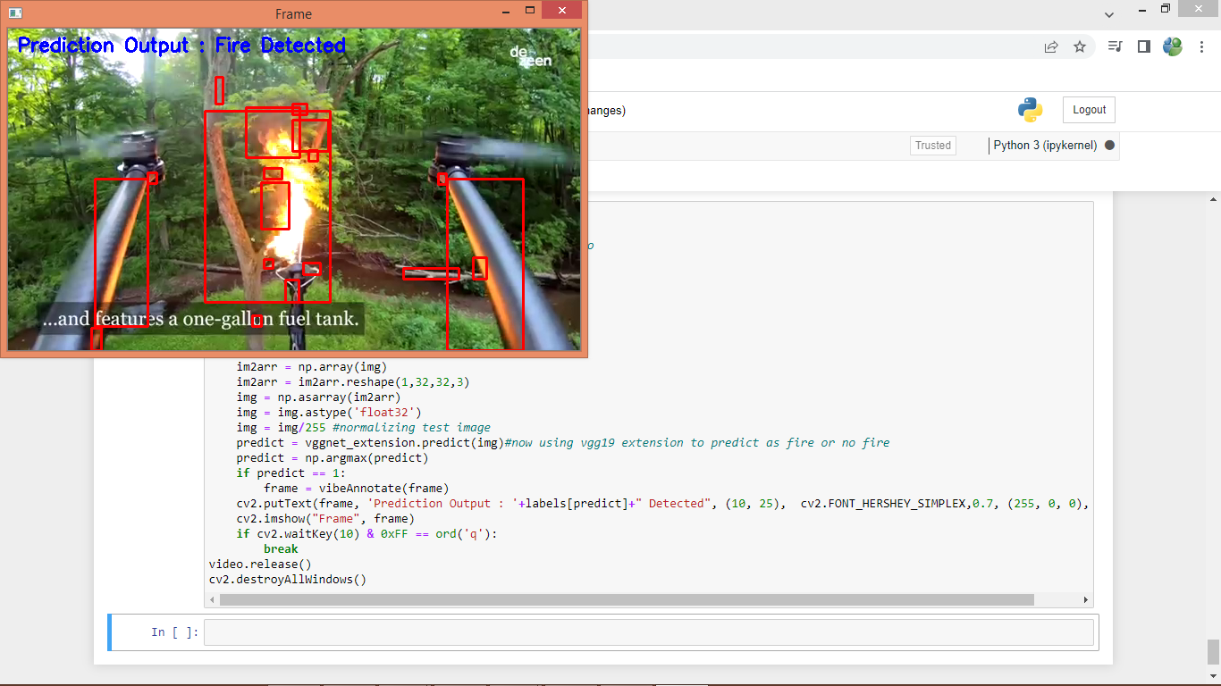
In above screen from video also we are detecting and annotating fire.

9. CONCLUSION
Our proposed deep learning-based model, Reduce-VGGNet, presents a significant advancement in forest fire detection, offering a solution to mitigate the substantial financial losses incurred by wildfires. Traditional manual monitoring methods are inadequate, and existing machine learning algorithms often lack real-time accuracy. By modifying the VGG16 algorithm and incorporating spatial and temporal features, Reduce-VGGNet achieves an impressive accuracy of over 97%, outperforming conventional approaches such as SVM and RCNN. Furthermore, the extension concept, leveraging VGG19 as the base classifier, demonstrates even higher accuracy, reaching 99.68%. Through rigorous evaluation using metrics like accuracy, precision, recall, and F1-score, our model consistently proves its effectiveness in fire detection.

10.BIBLIOGRAPHY

[1] A.Kumar, A. Kaur, and M. Kumar, ‘‘Face detection techniques: A review,’’ Artif. Intell. Rev., vol. 52, no. 2, pp. 927–948, 2019.
[2] M. J. Sousa, A. Moutinho, and M. Almeida, ‘‘Wildfire detection using transfer learning on augmented datasets,’’ Exp. Syst. Appl., vol. 142, Mar. 2020, Art. no. 112975.
[3] L. Wang, Y. Zhang, and X. Xu, ‘‘A novel group detection method for finding related Chinese herbs,’’ J. Inf. Sci. Eng., vol. 31, no. 4, pp. 1387–1411, 2015.
[4] B. Tang, J. Kong, and S. Wu, ‘‘Review of surface defect detection based on machine vision,’’ J. Image Graph., vol. 22, no. 12, pp. 1640–1663, 2017.
[5] S. Yin, Y. J. Ren, T. Liu, S. Guo, J. Zhao, and J. Zhu, ‘‘Review on application of machine vision in modern automobile manufacturing,’’ ActaOpticaSinica, vol. 38, no. 8, 2018, Art. no. 0815001.
[6] F. Min and T. Lu, ‘‘Exploration and practice of machine vision course teaching for production practice,’’ Comput. Educ., vol. 10, pp. 41–43, Jan. 2017.
[7] Z. Wang, G. Xiao, and H. Liu, ‘‘Teaching reform of the course of machine vision principles and applications for professional degree postgraduates,’’ Educ. Teaching Forum, vol. 3, no. 11, pp. 37–40, 2021.
[8] T. Shao, J. Tang, and Y. Liao, ‘‘Comprehensive experiment system of COCO on sorting based on machine vision,’’ Experim. Technol. Manag., vol. 37, no. 289, pp. 125–127&132, 2020.
[9] Z. Han and X. Liu, ‘‘Design of machine vision experiment teaching platform based on Python,’’ Comput. Meas. Control, vol. 258, no. 3, pp. 249–253, 2020.
[10] J. Sigut, M. Castro, R. Arnay, and M. Sigut, ‘‘OpenCV basics: A mobile application to support the teaching of computer vision concepts,’’ IEEE Trans. Educ., vol. 63, no. 4, pp. 328–335, Nov. 2020.
[11] M. Cote and A. B. Albu, ‘‘Teaching computer vision and its societal effects: A look at privacy and security issues from the students’ perspective,’’ in Proc. IEEE Conf. Comput. Vis. Pattern Recognit. Workshops (CVPRW), Honolulu, HI, USA, Jul. 2017, pp. 1378–1386.
[12] S. Spurlock and S. Duvall, ‘‘Making computer vision accessible for undergraduates,’’ J. Comput. Sci. Colleges, vol. 33, no. 2, pp. 215–221, 2017.
[13] Y. Jiang and B. Li, ‘‘Exploration on the teaching reform measure for machine learning course system of artificial intelligence specialty,’’ Sci. Program., vol. 2021, Nov. 2021, Art. no. 8971588.
[14] Y. Wang, M. Stankovic, A. Smith, and E. T. Matson, ‘‘Leader-follower system in convoys: An experimental design focusing on computer vision,’’ in Proc. IEEE Sensors Appl. Symp. (SAS), Aug. 2021, pp. 1–6.
[15] N. J. Abram, B. J. Henley, A. Sen Gupta, T. J. R. Lippmann, H. Clarke, A. J. Dowdy, J. J. Sharples, R. H. Nolan, T. Zhang, M. J. Wooster, J. B. Wurtzel, K. J. Meissner, A. J. Pitman, A. M. Ukkola, B. P. Murphy, N. J. Tapper, and M. M. Boer, ‘‘Connections of climate change and variability to large and extreme forest fires in Southeast Australia,’’ Commun. Earth Environ., vol. 2, no. 1, p. 8, Jan. 2021.
[16] O. M. Bushnaq, A. Chaaban, and T. Y. Al-Naffouri, ‘‘The role of UAVIoT networks in future wildfire detection,’’ IEEE Internet Things J., vol. 8, no. 23, pp. 16984–16999, Dec. 2021.
[17] G. Saldamli, S. Deshpande, K. Jawalekar, P. Gholap, L. Tawalbeh, and L. Ertaul, ‘‘Wildfire detection using wireless mesh network,’’ in Proc. 4th Int. Conf. Fog Mobile Edge Comput. (FMEC), Jun. 2019, pp. 229–234.
[18] N. T. Toan, P. Thanh Cong, N. Q. V. Hung, and J. Jo, ‘‘A deep learning approach for early wildfire detection from hyperspectral satellite images,’’ in Proc. 7th Int. Conf. Robot Intell. Technol. Appl. (RiTA), Nov. 2019, pp. 38–45.
[19] L. Jia and Y. Jiong, ‘‘Multi-information fusion flame detection based on Ohta color space,’’ J. East China Univ. Sci. Technol., vol. 45, no. 6, pp. 962–969, 2019.
[20] Y. Tan, L. Xie, H. Feng, L. Peng, and Z. Zhang, ‘‘Flame detection algorithm based on image processing technology,’’ Laser Optoelectron. Prog., vol. 56, no. 16, 2019, Art. no. 161012.

